Homework 2.6: Inverse Relations (Graphs & Tables) Name: ______________________
Math 3

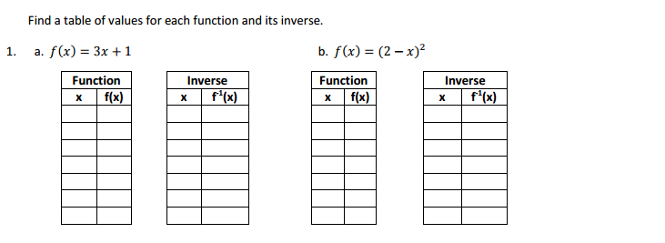

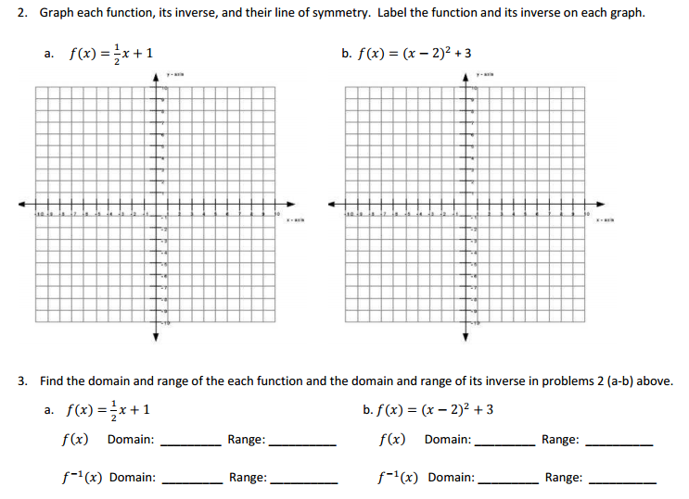

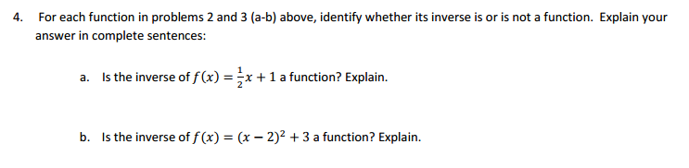

5. Find the inverse for each relation.

- {(1, -3), (2, 3), (5, 1), (6, 4)}
- {(-5, 6), (-6, -8), (1, -2), (10, 3)}

Directions: Graph the inverse for each relation below (put your answer on the same graph).
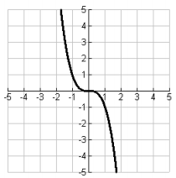

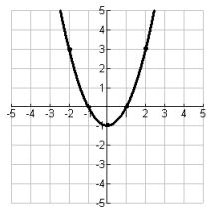
6.
7.

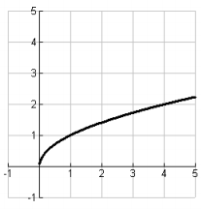
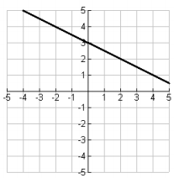

8.
9.

