Lesson 2.5 | Homework (Part 1)
- Graph
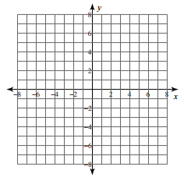
Transformations:

Domain:

Range:

End Behavior:

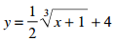
- Graph
Transformations:

Domain:

Range:

End Behavior:

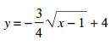
- Graph
Transformations:

Domain:

Range:

End Behavior:

