Homework 2.4: Applications of Piecewise Name: __________________________
Math 3

- Use the piecewise function to evaluate the following:
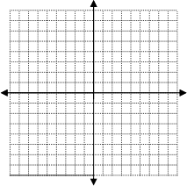
- Graph the following piecewise function.

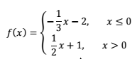
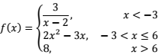

  - f(-1) =
  - f(-4) =
  - f(9) =
  - f(6) =
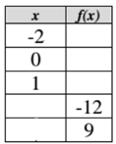
- Use the piecewise function to fill in the table.
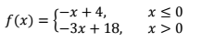

- Sully’s blood pressure changes throughout the school day. Sketch a graph of his blood pressure over time. LABEL THE GRAPH! Let x stand for the time since 8:00 am, so 10:00 am would be x = 2, 12:00 pm would be
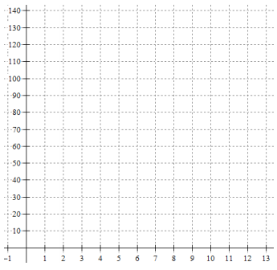
x = 4, etc…

Sully’s Day

- Sully’s blood pressure starts at 90 and rises 5 points every hour for the first 4 hours.

- Sully chills out for lunch from 12-1 and maintains a cool 110 blood pressure.

- Last period of the day is from 1-3 pm and Sully’s blood pressure rises from 110 at 10 points per hour.

- School ends and Sully’s blood pressure starts dropping 2 points per hour until his 8 o’clock bedtime.

- Use the picture of the piecewise function to answer the following:

Graph  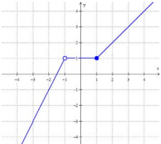 | Equation of Pieces | Domain for Pieces | Piecewise Function  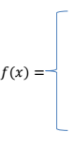

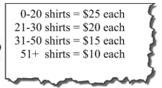
- Ms. Russell wants to make t-shirts for his Math 3 students (shown below). Custom Ink will make the shirts and sell them for the following prices. Write a piecewise function to represent cost, y, in dollars and t-shirts, x. Graph it! Label the graph!
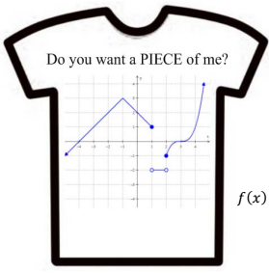

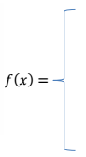

SAT Practice
- Minli’s house is located 1.4 miles from her school. When she walks home from school, it takes her an average of 24 minutes. Assuming that Minli walks at a constant rate, which of the following functions best models Minli’s distance from home, d, in miles if she has walked a total of t minutes on her trip home that day?  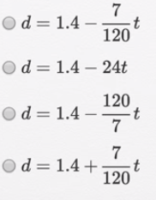 | - The absolute pressure, P, in a fluid density, p, at a given depth, h, can be found with the above equation, where P_{o} is the atmospheric pressure and g is the gravitational acceleration. Which of the following is the correct expression for the depth in terms of the absolute pressure, atmospheric pressure, fluid density, and gravitational acceleration?  