Homework 1.4: Solving Quadratics Name: _______________________
Directions: Solve #2-24 even, #25, 26, 27. Math 3

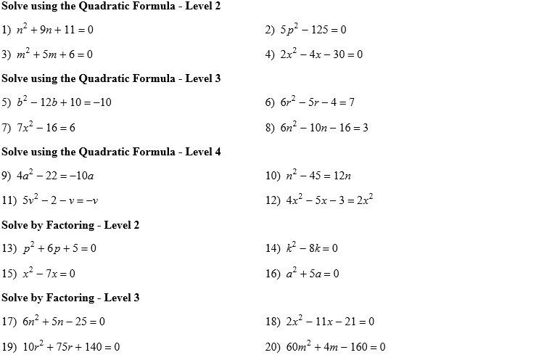
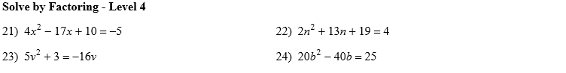

- The larger leg of aright triangle is 7 cm longer than its smaller leg. The hypotenuse is 8 cm longer than the smaller leg. How many centimeters long is the smaller leg?

- The area of a rectangular floor is 105 square feet. If its length is 1 more than twice its width, find the length and width of the floor.

- What is the smallest of 3 consecutive positive integers if the product of the smaller two integers is six less than 6 times the largest?

