Homework 1.3: Factoring Review Name: _______________________
Directions: Complete the evens in each column. Show work on a separate sheet of paper. Math 3

GCF Grouping

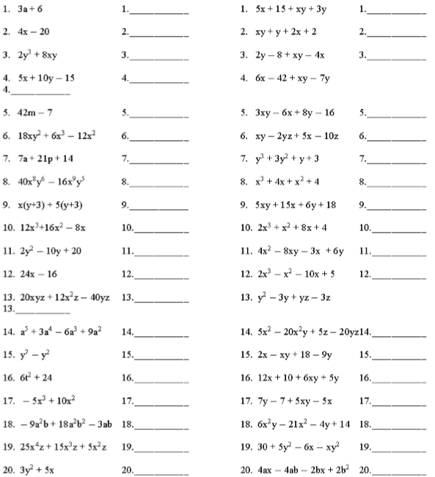

Binomials Trinomials
