Homework 1.2: Imaginary and Complex Numbers Name: _______________________
Complete #1-8 all, and #10-24 even Math 3

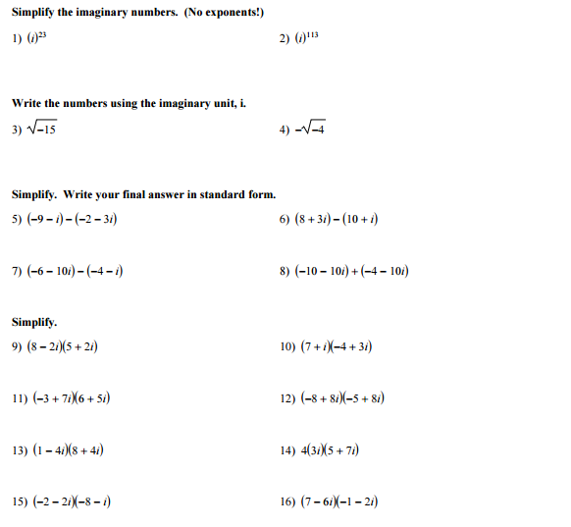

More on the back!

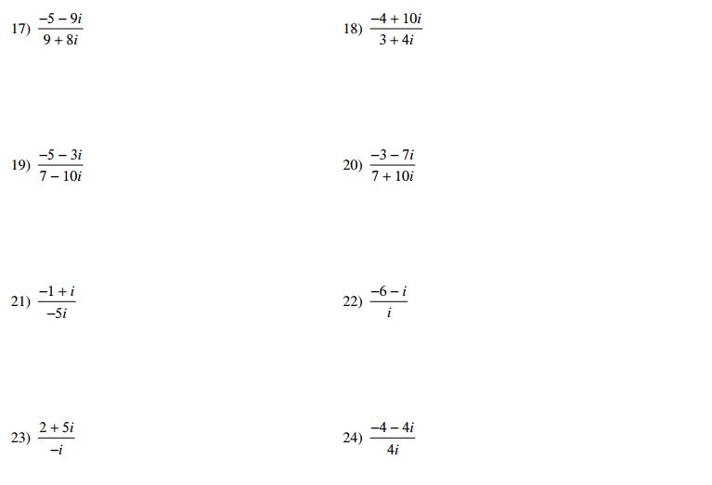

Answers:

- $–i$

- $i$

- $i\sqrt{15}$

- $-2i$

- $-7+2i$
- $-2+2i$
- $-2-9i$
- $14-20i$

10. $-31+17i$
12. $-24-104i$
14. $-84+60i$
16. $-19-8i$

18. $\frac{28-46i}{25}$
20. $\frac{-91-19i}{149}$
22. $-1+6i$

24. $-1+i$

