GRAPHING RADICAL FUNCTIONS

VOCABULARY

Radical function: A function that can be written in the form $f\left(x\right)=\sqrt[n]{x-h}+k, where a≠0$. For even values of n, the domain of a radical function is the real numbers x > h.

EX: $f\left(x\right)=\sqrt{x-2}$

Square Root Function: a function that can be written in the form $f\left(x\right)=a\sqrt{x-h}+k, where a≠0$. The domain of a square root function is all real numbers x > h.

EX: $f\left(x\right)=2\sqrt{x-3}+1$

Families of Radical Functions

 | SQUARE ROOT | RADICAL
Parent Function | $$y=\sqrt{x}$$ | $$y=\sqrt[n]{x}$$
Reflection in x-axis | $$y=-\sqrt{x}$$ | $$y=-\sqrt[n]{x}$$
Stretch: a > 1  Shrink: 0 < a < 1 | $$y=a\sqrt{x}$$ | $$y=a\sqrt[n]{x}$$
Translation  Horizontal by h  Vertical by k | $$y=\sqrt{x-h}+k$$ | $$y=\sqrt[n]{x-h}+k$$

Translating a Square Root Function

EXAMPLE #1: Graph $y=\sqrt{x+2}$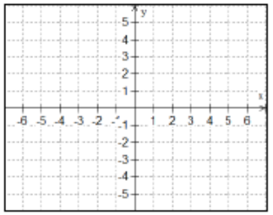

Domain: Range:

EXAMPLE #2: Graph $y=\sqrt{x}-4$

Domain: Range:

Graphing a Square Root Function

EXAMPLE #3: Graph $y=2\sqrt{x+3}-1$

Domain: Range:

EXAMPLE #4: Graph $y=-\frac{1}{2}\sqrt{x-1}+4$

Domain: Range:

