X-Intercept  Root, Zero, Solution |  |  |  |  |  | Y-Intercept
Axis of Symmetry |  |  |  |  |  | Vertex
“a” value |  |  |  |  |  | Domain & Range
Standard Form |  |  |  |  |  | Vertex Form
Where the graph crosses the y-axis.  - The value of x is always zero |  | 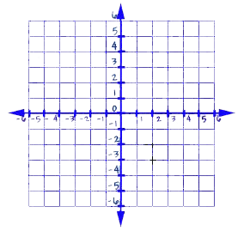 |  | Where the graph crosses the x-axis.  - The value of y is always zero  - Solve by factoring, quadratic formula, completing the square, or graphing.
The highest or lowest point (x, y) of a graph. |  |  |  | A line (x = ___) that cuts a graph into two symmetrical parts
Domain: The set of all x-values in a function |  | Range: The set of all y-values of a function |  | Determines the opening of the graph  - If “a” is positive, it opens up  - If “a” is negative, it opens down
*Where (h, k) is the vertex |  |  |  | *Where a, b, and c are just numbers

