RELAYS – SET ONE
1. Write the equation of a circle with a center at (-2,3) and a point on the circle is (1,8).

2. Find all the zeros of the function f(x) = x³ + 27

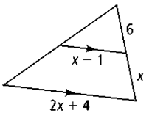
3. Find the values of x.

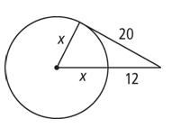
4. Find the value of x to make this line tangent to the circle.

ANSWERS:
1. 2.

3. 4.

RELAYS – SET TWO
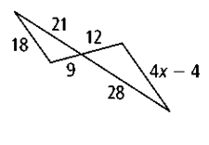
1. Find the value of x

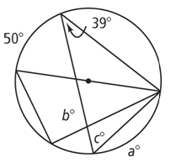
2. Find the values of a, b, and c.

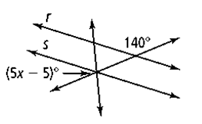
3. Find the value of x.

4. Write the equation of a polynomial function with zeros at 4 and 3i.

ANSWERS:
1. 2.

3. 4.

RELAYS – SET THREE
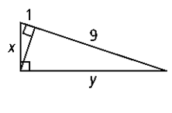
1. Find x and y.

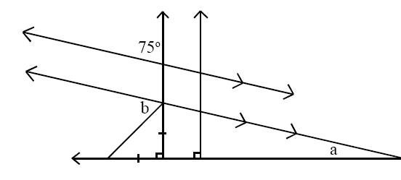
2. Find a and b.

3. Draw an angle that measures $-240°$.

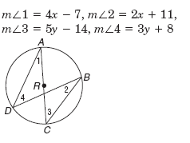
4. Solve for x and y.

ANSWERS:
1. 2.

3. 4.
RELAYS – SET FOUR
1. List out the five ways to prove triangles congruent.

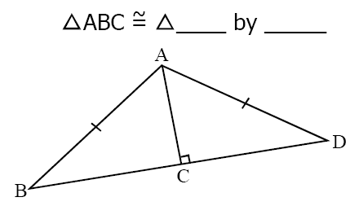
2.

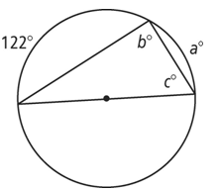
3. Find a, b, and c.

4. Describe all the transformations in the graph of $f\left(x\right)= -\left|x+3\right|$ from the parent graph $f\left(x\right)= \left|x\right|$

ANSWERS:
1. 2.

3. 4.

