Exponents Study Guide Name: _______________________

Math 1 Date: ____________ Block: ____

**Directions:** Simplify each expression. Use positive exponents.

1. 
2. 
3. 



1. (*m*3*n*–5*m*–1)–3
2. 
3. If z = ½, which expression has the greatest value?
4. *z*–6*z*4
5. (*z*–2*z*5)–2
6. (*z*3)5
7. –(*z*2*z*–4)–3

Simplify the following:

1. 
2. 
3. (*x–*2)–5
4. (*x*2*y–*2)(*xy*)4

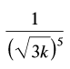

Write using rational exponents.

1. 
2. 
3. 

Write using radicals.

1. 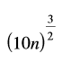
2. 
3. 
4. 

Graph each function. Make sure to draw a dotted line for the horizontal asymptote.

$f\left(x\right)= \frac{1}{3}∙3^{x}-2$

$y=3∙{(\frac{1}{3})}^{x}+2$

3. *y =* 0.5*x + 3*

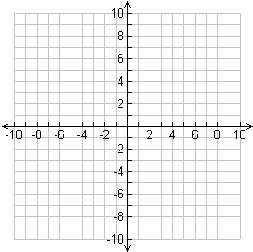

1. Your other grandfather owns two new cars. His 2007 Honda is worth $16,000 and its value depreciates at a rate of 8% per year. His 2007 Ford is worth $21,000 and depreciates at a rate of 11% per year.
   1. How much will the Honda be worth in 2012?
   2. How much will the Ford be worth in 2015?
2. The function *y =* 195 • 0.75*x* models the average time (in minutes) of math tests in 1980.
   1. Does the exponential function represent *growth* or *decay*?
   2. Estimate the average time for math tests in 1990.
   3. Predict the average time for math tests in 2025.
3. Find the balance in a bank account after 8 years if $500 is invested at 7% interest.
4. Find the balance in a bank account after 5 years if $2000 is invested at 6% interest.
5. On the first swing, a pendulum swings through an arc of length 60 cm. On each successive swing, the length of the arc is 82% of the length of the previous swing.
   1. Write a rule to model this situation.
   2. Find the length of the arc on the fifth swing. Round your answer to the nearest cm.
6. **Reasoning**: Does the table below represent an exponential function? Explain why or why not.

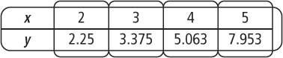

1. 