Up and Up  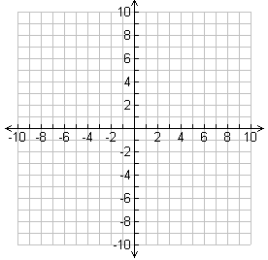 | Down and Down | Up and Down | Down and Up

Up and Up | Down and Down | Up and Down | Down and Up

Up and Up | Down and Down | Up and Down | Down and Up

