|  |  |
| --- | --- |
| Lesson 2.1 | Homework |

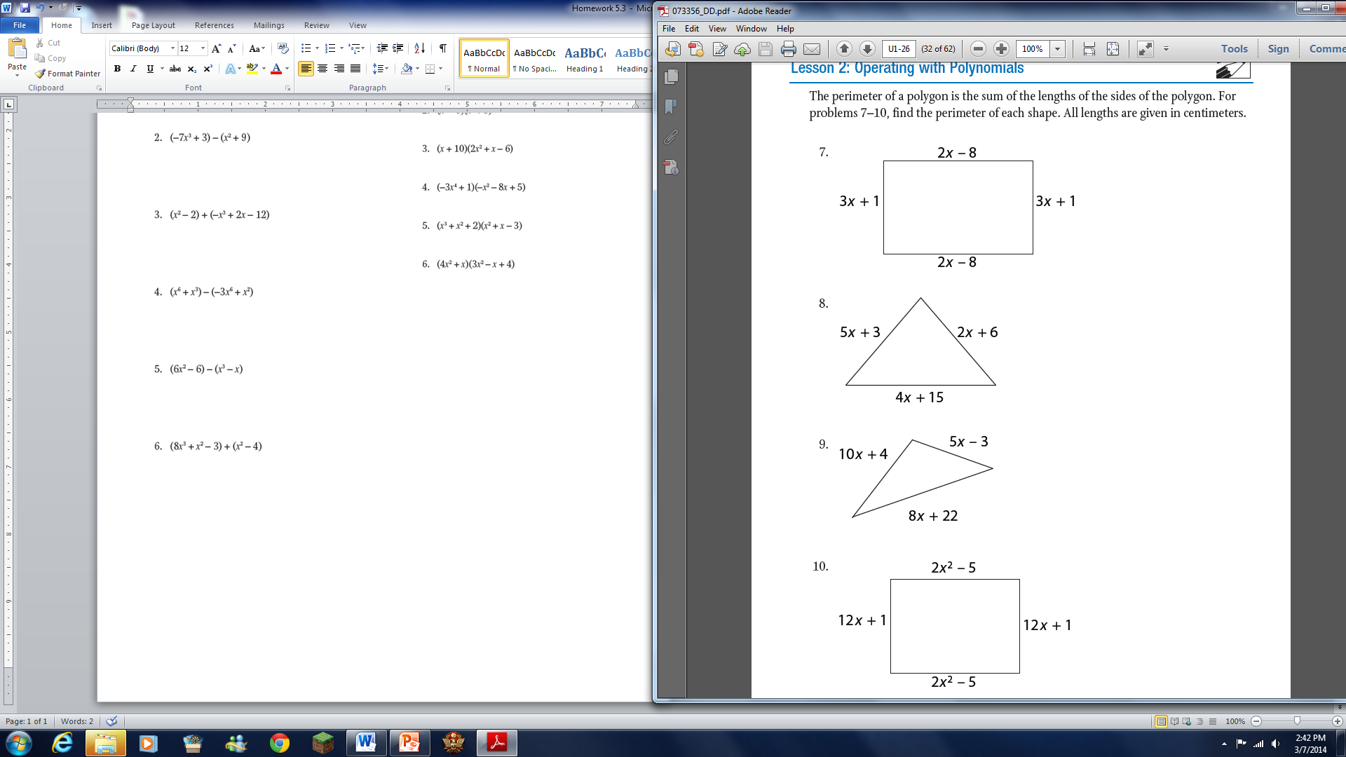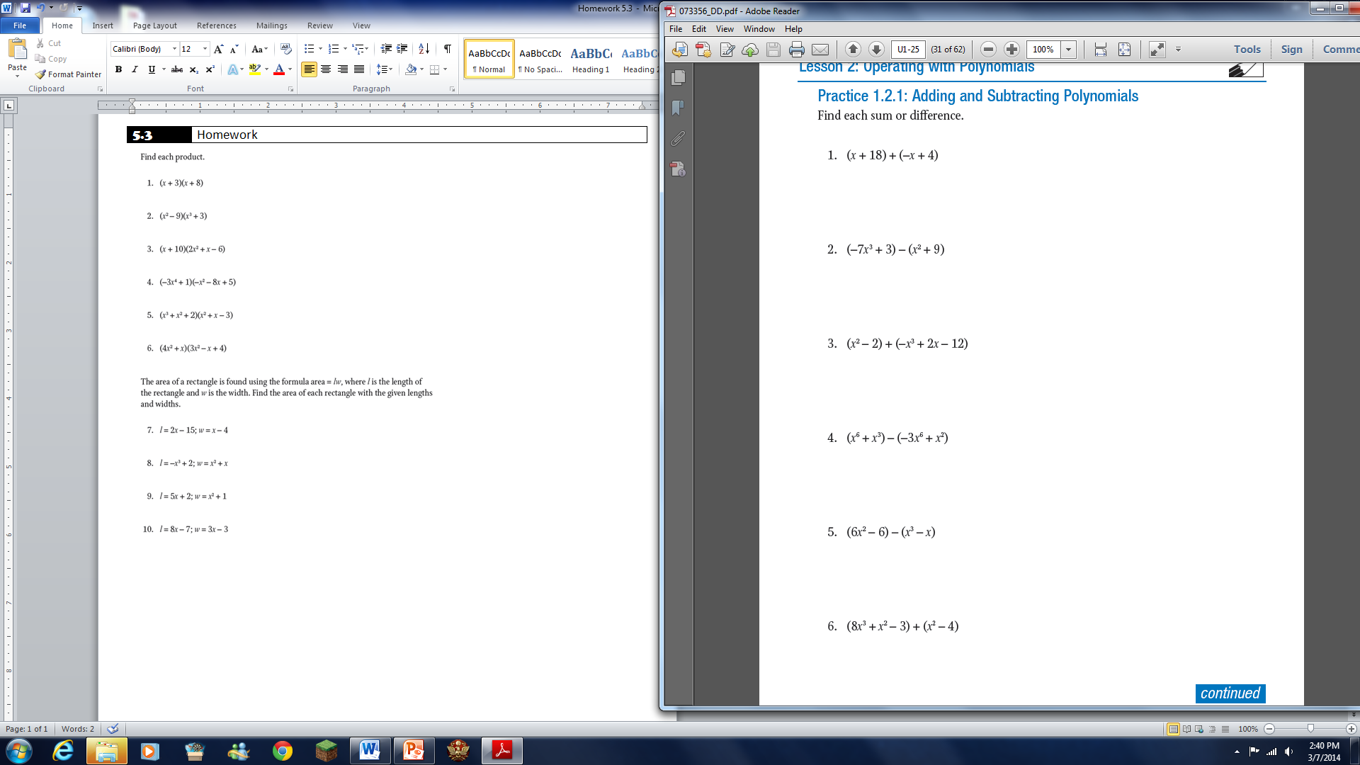

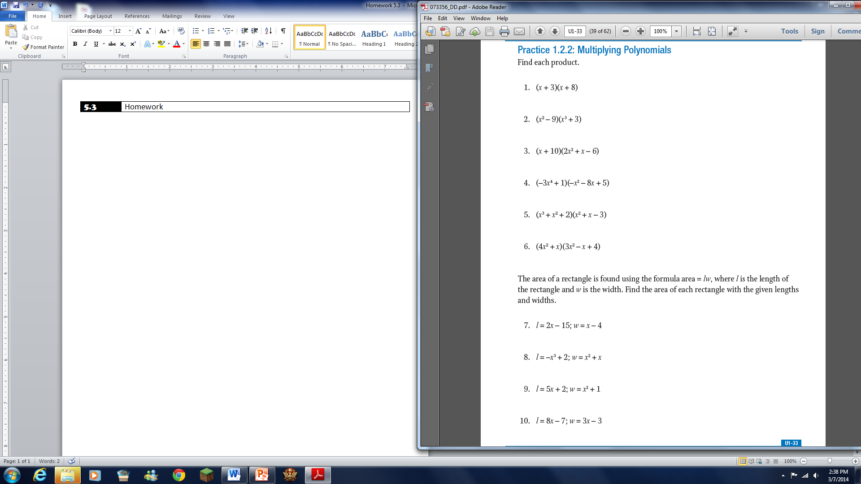

16.

15.

14.

13.

12.

11.