1.10 Homework: Writing a Quadratic Equation with a Point and a Vertex

Directions: Write a quadratic equation in vertex form which has a graph with the given vertex and passes through the given point.

- Vertex: (2, -1)
Point: (4, 3)
- Vertex: (-4, 6)
Point: (-1, 9)

- Vertex: (4, 5)
Point: (8, -3)
- Vertex: (0, 0)
Point: (-2, -12)

- A suspension bridge has two 400 foot towers that are 800 feet apart with a cable secured to either end of the span, and then draped off the tower forming a parabola that is 60 feet from the bridge surface. Write a quadratic function in vertex form to represent the suspension cable using the height of the tower on the left as the y-intercept. What is the height of the cable 40 feet to the right of the tower? (Label the picture below to help)

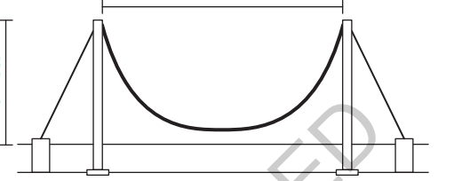

- A Native American burial mound has a cross section that is parabolic. The mound is 100 feet wide and has a maximum height of 50 feet at its center. Using the left edge as the origin, write a quadratic equation in vertex form the parabolic cross section described. If you go a horizontal distance of 80 feet from the origin, what is the height of the mound?

