**Hypotenuse Leg (HL)**

|  |  |
| --- | --- |
| **Statement** | **Reason** |
| 1. | 1. |
| 2. | 2. |
| 3. $∆PRS and ∆RPQ$ are right triangles | 3. |
| 4. | 4. Reflexive Property |
| 5. $∆PRS≅∆RPQ$ | 5. |

**Example 1:**

Given: $∠PRS and ∠RPQ$ are

right angles.

$\overline{SP}≅\overline{QR}$

Prove: $∆PRS≅∆RPQ$

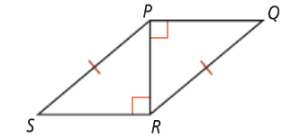

**Corresponding Parts of Congruent Triangles are Congruent (CPCTC)**

|  |  |
| --- | --- |
| **Statement** | **Reason** |
|  | 1. |
|  | 2. |
|  | 3. |
|  | 4. SSS |
|  | 5. |

**Example 2:**

Given:  

Prove: 

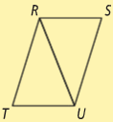

|  |  |
| --- | --- |
| **Statement** | **Reason** |
| 1. | 1. |
| 2. | 2. |
| 3. | 3. |
| 4. | 4. Right angles are congruent |
| 5. | 5. |
|  | 6. |

**Example 3:**

Given:  

 andare

both right angles.

Prove: 

