Angle of Elevation and Depression
Math Lib

(1) ________________was (2) ________________ to be (3) _____________________ with
(4) ________________ on (5) _______________ at (6) ________________ in (7) ________________ wearing (8) _________________ while (9) _________________ because they wanted (10) _________________!

Angle of Elevation and Depression
Math Lib

(1) ________________was (2) ________________ to be (3) _____________________ with
(4) ________________ on (5) _______________ at (6) ________________ in (7) ________________ wearing (8) _________________ while (9) _________________ because they wanted (10) _________________!
1.

Anisa is stuck at the top of a Ferris wheel. Her mother is standing 38 feet from the base of the wheel watching her. If the angle of elevation from Anisa’s mom to Anisa is 73°, how far is Anisa off the ground?

- 118.2 ft Ms. Cook
- 120.9 ft Ms. Russell
- 124.3 ft Mr. Wonsavage
- 126.5 ft Mr. Green
- 128.1 ft Ms. Connor
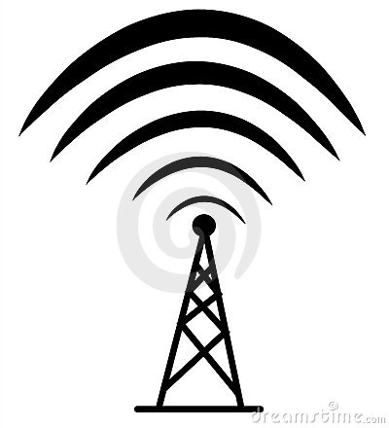
2.

Christian is wiring a radio transmission tower that is 170 feet tall. How long should the wire be if it is to be attached 8 feet from the top and is to make an angle 29° from the ground?

- 334.2 ft predicted
- 194.4 ft pictured
- 185.2 ft presented
- 350.7 ft spotted
- 421.6 ft baited

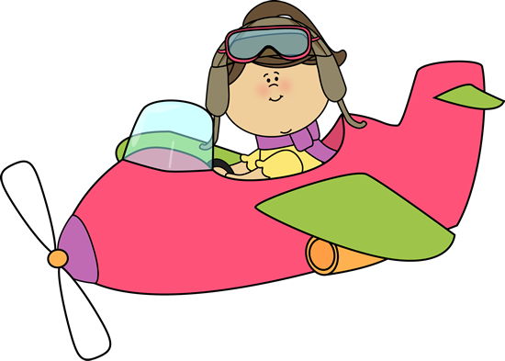
3.

An airplane over the Pacific sights a reindeer at an angle of depression of 5°. At this time, the horizontal distance from the airplane to the reindeer is 4629 meters. How high is the airplane to the nearest meter?

- 403 m wiggling
- 405 m dancing
- 4611 m rolling his eyes
- 4647 m canoodling
- 421 m snuggling

4.

To approach the runway, a small plane must begin a 9° descent starting from a height of 1125 feet above the ground. How many miles from the runway is the airplane at the start of this approach?

- 1.3 mi J-Lo
- 1.4 mi Jennifer Lawrence
- 0.2 mi Betty White
- 7,191.5 mi Kate Middleton
- 5.3 mi Oprah

5.

To find the height of a pole, Darren moves 140 feet away from the base of the pole, and then, with a transit 4 feet tall, measures the angle of elevation to the top of the pole to be 44°. What is the height of the pole to the nearest foot?

- 145 ft Memorial Day
- 149 ft Labor Day
- 135 ft Christmas
- 139 ft Halloween
- 152 ft July 4th
6.

A spotlight is mounted on a wall 7.4 feet above a security desk in an office building. It is used to light an entrance door 9.3 feet from the desk. What is the angle of depression from the spotlight to the entrance door?

- 39° the Grand Ole Opry
- 51° a honky-tonk
- 53° the Whitewater Center
- 37° the beach
- 43° jail
7.

Find the angle of elevation of the sun from the ground to the top of a tree when a tree that is 10 yards tall casts a shadow 14 yards long. Round to the nearest degree.

- 54° Vegas
- 36° Nashville
- 46° Detroit
- 44° Charlotte
- 21° Boston
8.

Alivia is attempting to dive from a diving board 6.9 feet high into a tube that is located 12 feet diagonal from the edge of the board. What should be her angle of depression to ensure she hits the tube?

- 30.5° sunglasses
- 31.9° bow-ties
- 32.2° gorilla costumes
- 33.7° tu-tus
- 35.1° snow suits
9.

A large totem pole in the state of Washington is 100 feet tall. At a particular time of the day, the totem pole casts a 249-ft long shadow. Find the angle of elevation of the shadow to the top of the tree.

- 68° talking to the President
- 45° sleeping
- 35° twerking
- 22° eating Sonic
- 76° painting
10.

The angle of elevation from Gaylan to a cell phone tower is 75°. If Gaylan is standing 28 feet from the base of the tower, find the height of the cell phone tower.

- 104.5 ft to impress everyone
- 105.8 ft to promote world peace
- 106.1 ft to show how cool they are
- 107.4 ft to get out of the house
- 108.9 ft to make people jealous

