naming angles

Angles are usually named with

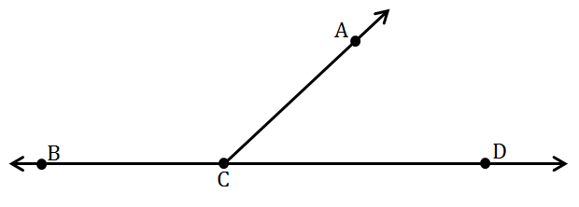

$$∠ACB$$

$$∠ACD$$

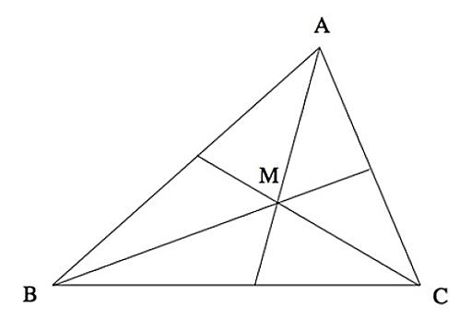 |  | $$∠AMB$$  $$∠BMC$$  $$∠ACB$$ | 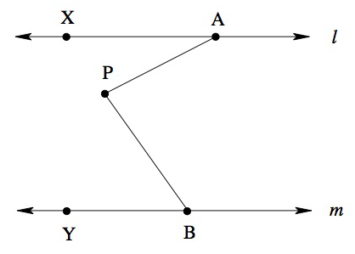 |  | $$∠PBY$$  $$∠PAX$$  $$∠APB$$
$$∠EBC$$  $$∠ABC$$ | 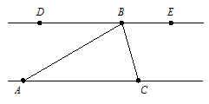 |  |  | $$∠DBA$$  $$∠DBC$$

Angle Addition Postulate
Part + Part = Whole

- Find the m∠ZBC if m∠ABC = 115 and m∠ABZ = 45.
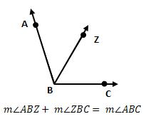

- Find the measure of ∠ADB and ∠BDC if m∠ADC = 86

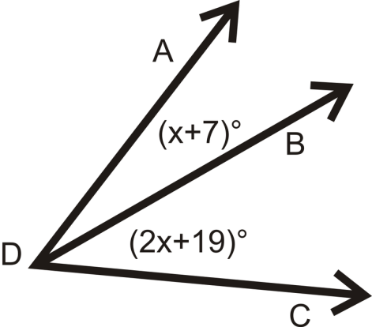

- The m∠DRE = 2x + 10, m∠ERF = 3x - 8, and m∠DRF = 134. What are m∠DRE and m∠ERF?

