A line or ray that cuts a segment or angle in half (into two equal parts) |  | Measure
Same or equal. Denoted by the same number of “tick” marks. |  | Bisector
Middle of a line. |  | Congruent
Measure refers to the opening of an angle. |  | Midpoint
Length refers to the distance of a line segment. |  | Length
 |  | 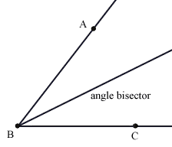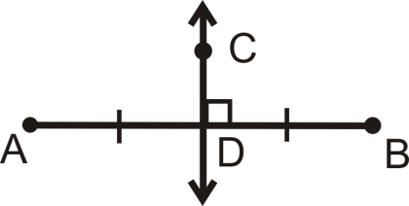
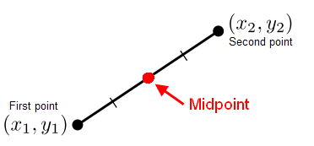 |  | 