Math II Triangle Angle Sum Theorem
Triangle Exterior Angle Theorem

Find all missing variables.
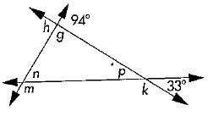 | 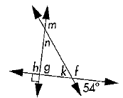  2. | 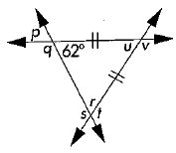  3.
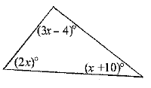  4. | 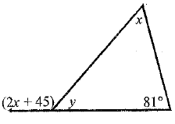  5. | 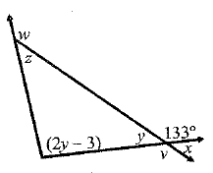  6.
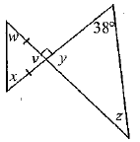  7. | 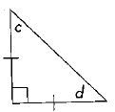  8.

Find all missing variables.
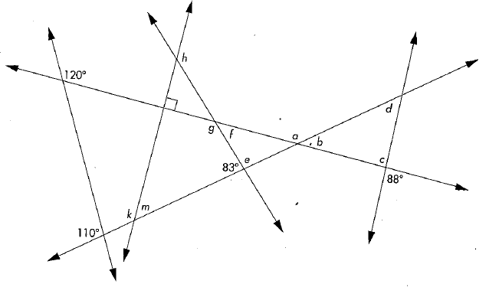

Math II Triangle Angle Sum Theorem
Triangle Exterior Angle Theorem

Find all missing variables.
 | 2. | 3.
4. | 5. | 6.
7. | 8.

Find all missing variables.

