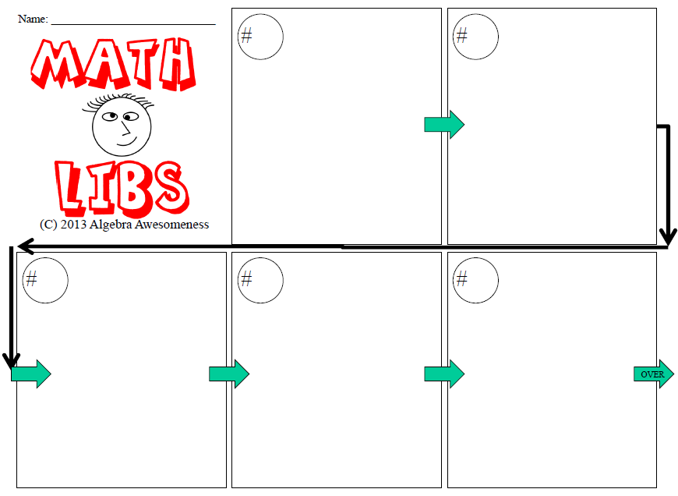

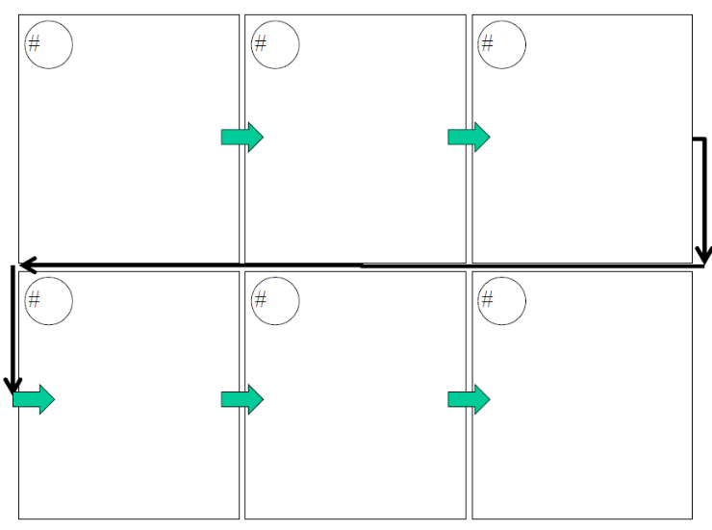

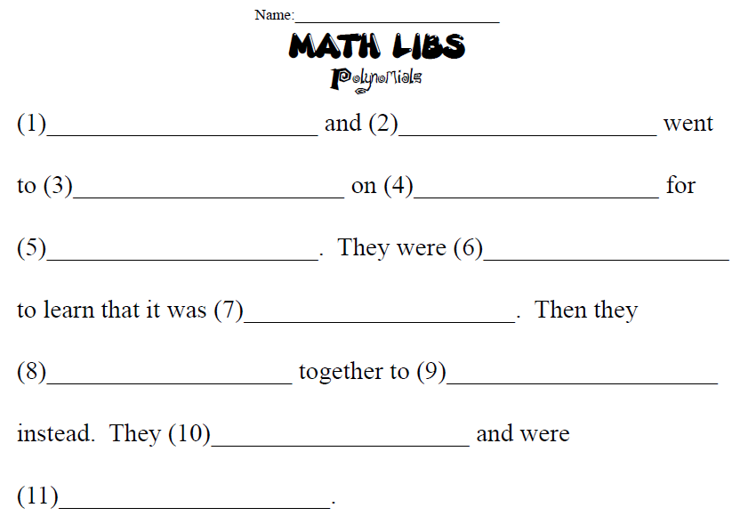

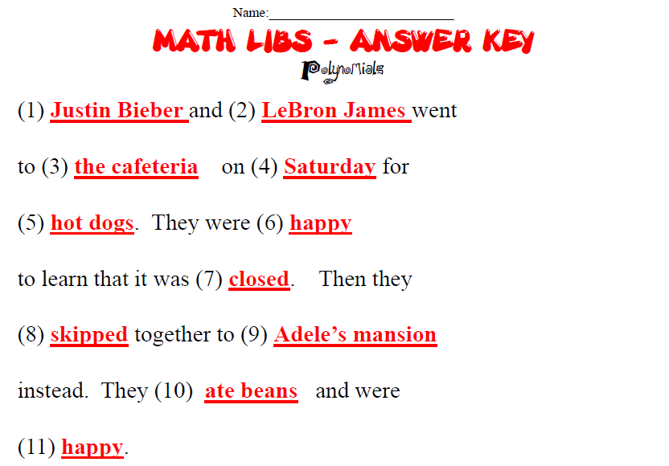

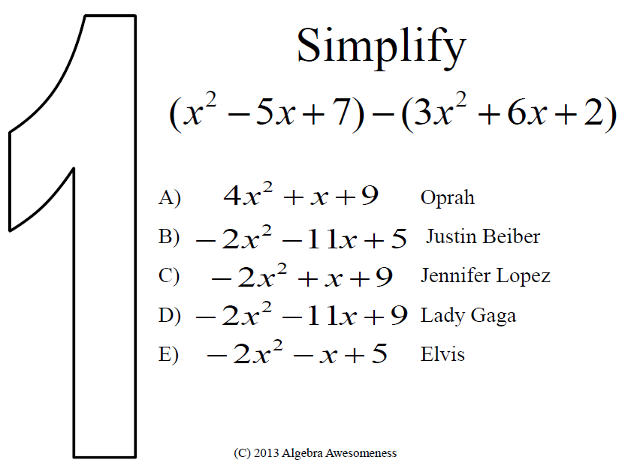

Which expression is equivalent to the perimeter of the shaded region of the rectangle?

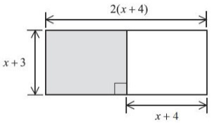

- 2x + 10 Alec Diaz
- 2x + 12 Missy Elliott
- 4x + 14 LeBron James
- 8x +28 Michaelah Pittman
- 6x + 20 Madonna
What is the sum of
(4x² + 5x – 8) and
(3x² – 6x + 1)?

- 7x² + x – 7 Jasper’s House
- 7x² – x – 7 the cafeteria
- 7x² + x + 7 the interstate
- 7x² – x + 7 a 1D concert
- x² + x – 7 the CIA

Which expression is equivalent to 3x² + 4x – 1?

- (x² + 3x – 1) – (2x² + x) Sunday
- (3x ² – 8) + (4x² + 7) Monday
- (2x² + 4x + 1) – (–x² + 2) Saturday
- (2x² + 4x + 1) + (–x² + 2) Friday

Find the difference:
(–7x²y + xy + 3x + 2) – (5x²y – 5xy – 6x – 7)

- –2x²y – 4xy – 2x – 5 Skittles
- –12x²y + 6xy + 9x + 9 hot dogs
- –12x²y – 6xy – 9x – 9 war heads
- 12x²y + 6xy + 9x + 9 muffins

Find the sum:
(x²y + 3x + 2) + (2 + 2xy² + 3x)

- x²y + 2xy² + 6x + 4 blissful
- 3x²y + 6x + 4 eager
- 3xy² + 6x + 4 poignant
- 3x²y² + 6x + 4 irate

Find the perimeter of the figure below:
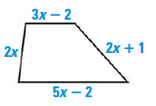

- 12x⁴ – 3 Open
- 12x – 5 Distraught
- 12x + 5 Dirty
- 12x – 3 Closed
- 12x – 4 Hopeful

Find the perimeter of the rectangle below:
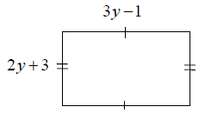

- 5y + 2 Hopped
- 10y + 4 Skipped
- 5y² + 2 Tickled
- 10y⁴ + 4 Sneezed

If the perimeter of the figure below is 15x + 7, find the length of the missing side.
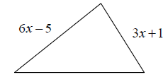

- 6x +11 Adele’s Mansion
- 24x +3 Burger King
- 6x +3 Buddy’s Pizza
- 12x + 13 A Panther’s Game

If the perimeter of the figure below is 11x² + 6x + 9, find the length of the missing side.
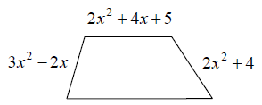

- 18x² + 8x + 18 sang songs
- 4x² + 4x ate beans
- 4x² + 8x + 18 watched LOST
- 4x² – 4x – 18 hugged

Expand and Simplify:
4(2x – 7) – 5(4x + 9)

- –28x – 73 Full
- –12x – 73 Happy
- –12x +17 Sleepy
- 12x + 48 Excited

