Statement | Reason
- $\overline{BC}≅\overline{BF}$ | 1.
- $\overline{CD}≅\overline{FD}$ | 2.
- $\overline{BD}≅\overline{BD}$ | 3.
- $∆BCD≅∆BFD$ | 4.
Example 1:

Given: $\overline{BC}≅\overline{BF}, \overline{CD}≅\overline{FD}$
Prove: $∆BCD≅∆BFD$
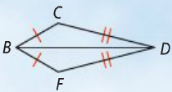

Statement | Reason
1. | 1. Given
2. | 2. Definition of segment bisector
3. | 3. Given
4. | 4. Definition of segment bisector
 | 5. Vertical Angles Theorem
 | 6. SAS Postulate
Example 2:

Given: $\overline{VZ} bisects \overline{XY}$;
$$\overline{XY} bisects \overline{VZ}$$
Prove: $∆XVW≅∆YZW$
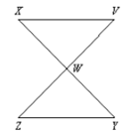

Statement | Reason
1. | 1. Given
2. | 2.
3. | 3. Given
4. | 4. All right angles are congruent
5. | 5.

Example 3:

Given: $\overline{LM}≅\overline{PO}, ∠L≅∠P$
$∠M and ∠O are right angles$

Prove: $∆LMN≅∆PON$

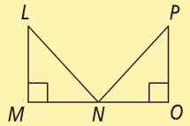

Statement | Reason
1. | 1.
2. | 2.
3. | 3.
4. | 4.
5. | 5.
Example 4:

Given: $\overline{RP} bisects ∠SRQ,$
$$∠S≅∠Q$$
Prove: $∆SRP≅∆QRP$
