Standard 7.G.6 Applications of Geometry Unit 2 Day 15
Geometry Review:
Types of Triangles:
Types of Quadrilaterals:
Types of Polygons:

Area Application Problems:
How much canvas will Matthew need for his new triangular sail if the height must be 18 ft and the base must measure 23 ft? If the canvas cost $15 a square foot how much will he pay for the canvas?  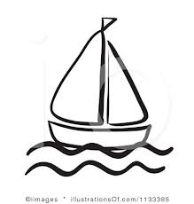 |  | You friend is buying new carpet for her rectangular room. The room is 12 ft long and 8 ft wide. If carpet cost $4.50 /ft² how much will the carpet cost?
A volleyball court is 18 m long and 9m. wide. It is divided into 2 halves. What are the perimeter and the area of each half? |  | Dan has decided to plant a garden. He wants to make it 10m long and 4m wide. In order to keep the rabbits out, Dan needs a fence surrounding the garden . He decides to make the fence 11m long and 5m wide. What is the area between the fence and the garden?  ( Hint: find the area of the garden and then the area surrounded by the fence.)
VOLUME
Volume of a rectangular Prism: | Volume of a cylinder: |  | Volume of a cube:
Surface area of a prism:

Practice:
Find the volume:  2 in  5 in  20 in | Find the volume:  8 m  5 m
Find the volume  5 yd. | Find the surface area:  2 in.  4 in.  2 in.
Application:
A town wants to build a sandbox at the local park. The required dimensions are 20ft by 7 ft. OSHA requires that the depth of the sandbox is 2 feet.

- How much sand do they need?

- If sand cost $.50 for every cubic foot, how much will the town spend on the sand alone?

