Standard 6.NS.5 Identify and Label Positive and Negative Numbers Unit 1 Day 8
Using a Number Line

Positive and Negative Numbers
Remember that distance is always ________________.
Negative numbers imply ________________.

To graph a number on a number line:
If it is negative: Start at 0, then count to the ____________.
If it is positive: Start at 0, then count to the ____________.

- Graph the following on a number line: A at -3 , B at -8.5, C at 5.25, D at -6/5, E at -17/2

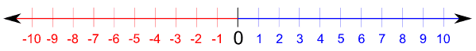

- Graph the following fractions on the positive number lines provided:
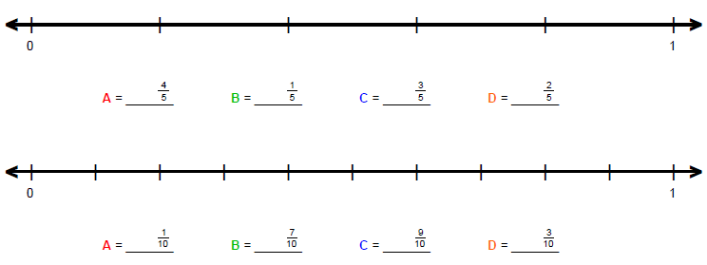

- Graph the following fractions on the positive number lines provided:

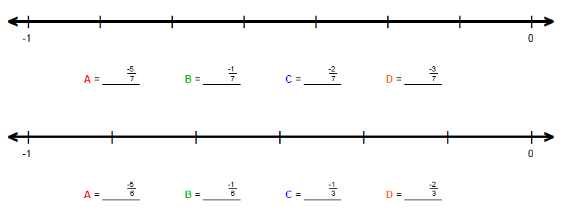

- Graph the following decimals on the positive number lines provided:
