Standard 6.NS.1 Multiply and Divide Rational Numbers Unit 1 Day 6

Identification Review
There are three types of fractions:
- __________________________ Example: $\frac{4}{5 }$
- _________________________ Example: $2\frac{1}{3}$
- _________________________ Example: $\frac{13}{12}$
The easiest way to multiply or divide fraction is to use improper fractions and proper (common) fractions ONLY!

Multiplying Fractions
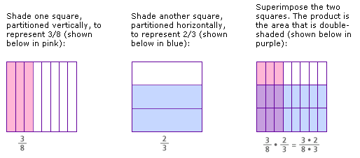

Example 1: Multiply the following.

- $\frac{4}{5 }×\frac{4}{5 }=$
- $\frac{4}{2 }∙ \frac{4}{5 }=$

- $\frac{1}{3}×\frac{4}{7 }=$
- $\frac{2}{3} ×\frac{4}{15 }=$

- $1 \frac{2}{5 }∙\frac{4}{5 }=$
- $2 \frac{2}{3 }∙4\frac{1}{6}=$

Dividing Fractions
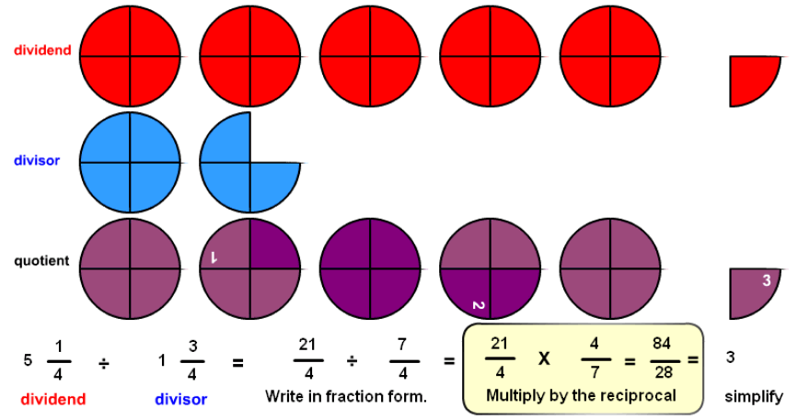

Example 2: Divide the following.

- $\frac{2}{5 }÷\frac{4}{5 }=$
- $\frac{1}{2 }÷\frac{1}{5 }=$

- $\frac{1}{3}÷\frac{2}{7 }=$
- $\frac{3}{4}÷\frac{1}{6 }=$

- $\frac{1}{5 }÷\frac{4}{5 }=$
- $\frac{1}{2 }÷\frac{6}{5 }=$

- $\frac{1}{2}÷\frac{2}{7 }=$
- $\frac{9}{4}÷\frac{1}{6 }=$

