Standard Math 1 4.1 Using Graphs to Relate to Two Quantities Unit 1 Day 1

Example 1: The following graph shows the distance traveled by a school bus based on every morning from 6:30-7am.
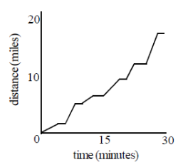
- What do the flat sections of the graph represent?

- What do the steep sections of the graph represent?

- Which is the best estimate of the busses average speed: 17mph, 20mph, 34mph, 50mph?

- Why doesn’t the path of the line ever go down?

Often you will need to recognize graphs plotting distance versus time, or distance from a point versus time, usually with the time plotted on the x-axis.

Distance is called a _________________________ of time.

Example 2: Match each graph below with the appropriate situation.
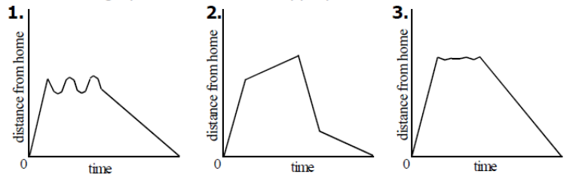
- Mary leaves the house, walks to the store, and returns with groceries.

- Roger walks around the block.

- Sylvia runs to the track, takes a few laps, and then runs home.
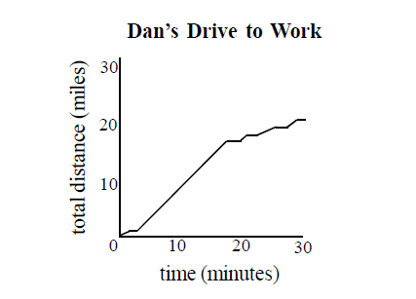

Example 3: Use the graph to the right to answer each of the following.
- When is Dan driving on the highway?

- Approximate Dan’s average speed for the trip to work.

- Approximate Dan’s top speed on his way to work.

Example 4: Use the graph below to answer each of the following.
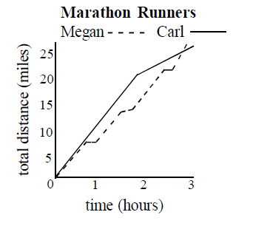
- Who finishes the marathon first?

- How do Megan and Carl’s strategies compare?

- Approximately how many minutes does it take Carl to run each mile during the first 1:40 of the race? (4, 5, 6, or 7 minutes?)

Standard Math 1 4.6 Relations and Functions Unit 1 Day 1
Relation: A set of ___________________ _______________. It can be written as ________________________, __________________, or a __________________.

Domain: The set of _______ values in an ordered pair. Range: The set of _______ values in an ordered pair.

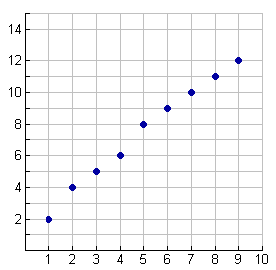
Example 1: List the domain and range for each relation.

- (4, 0) (2, 8) (6, -1) (10, 4)

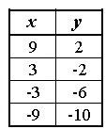

Function: A relation in which every x value has only one y value. The X’s can’t ________________!!!!!
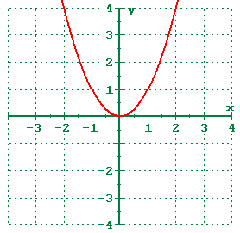
Example 2: Are the following functions?

- (2, 4) (3, 5) (5, 10) (2, 7)

- (1, 1) (2, 2) (3, 3) (4, 4) (5, 5)

Vertical Line Test: A way to test if a graph is a function or not.

Example 3: State if the graph is a function by using the vertical line test.

Function Notation: To write a rule in function notation, you use the symbol ________ instead of _____. It is read “F of X”

Example 4: Evaluate each of the following.

- y = 3x + 4 if x = 4
- f(x) = 3x + 4 if f(6)
- f(x) = -12x + 1 if f(3)

