Math 1 Two-Way Tables Unit 4

Two-Way Tables: A way of organizing data

Example 1: Complete the class data chart below:
 | Has a Dog | Does not have a dog | Total
Has a Cat
Does not have a cat
Total

Now find the proportions of each box compared to the total class (divide the number in each box by the total number of students in the class).

- How many students have a cat and a dog?

- How many students have a cat?

- What percent of students do not have a dog or a cat?

- What percent of students have a dog?

Example 2: Complete the two-way table below:
 | iPhone | Droid | Neither | Total
Verizon
AT&T
Neither
Total

- How many students have an iPhone and Verizon?

- How many students have AT&T?

- What percentage of students has a Droid?

- What percentage of Verizon subscribers have an iPhone?

- How many people have neither an iPhone, Droid, Verizon, nor AT&T?

Example 3: During one month, exactly half of the 180 babies born in a hospital were boys, and 40 babies weight 8 pounds or more. There were 26 baby boys who weighed 8 pounds or more.
 | Less than 8 lbs | 8 lbs or more | Total
Boys
Girls
Total

- What is the relative frequency of baby girls who weighed 8 lbs or more?
- What percentage of baby boys weighed 8 lbs or more?
- What percentage of babies born were girls?

Example 4: Complete the two-way table for 9th Grader’s school transportation survey:
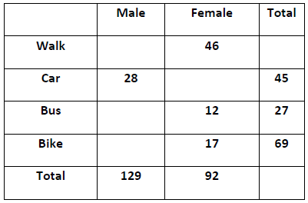
- What percent of 9th grade girls walk to school?

- What percent of 9th graders are girls who walk to school?

- What percent of students ride the bus?

- What percent of boys ride their bike?

Example 5: Before the ACT, 200 students were pulled to see how many of them studied for the exam. The results are shown in the table below.
STUDY FOR THE TEST
 | Yes | No | Maybe | Total
Boys | .25 | .15 |  | .56
Girls |  |  | .16
Total | .52 | .16 |  | 1.00

- What percentage of boys studied for the ACT?

- What percentage of girls did not study for the ACT?

- How many students did study for the ACT?
- How many boys were in the survey?

- How many girls maybe studied for the ACT?
- How many of the students who did study for the ACT were girls?

