**Systems of Equations: EOC Prep** Name: ___________________________

Spring 2013

**Directions:** The following questions are sample items similar to those found on the EOC Exam. Answer each to the best of your ability.

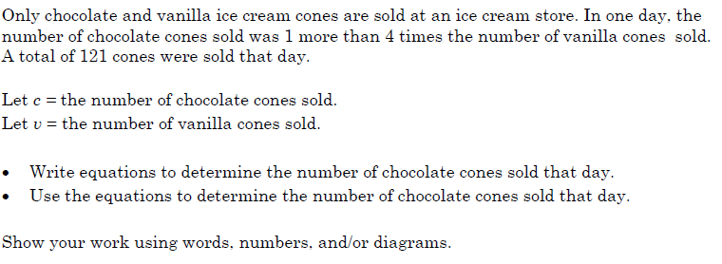



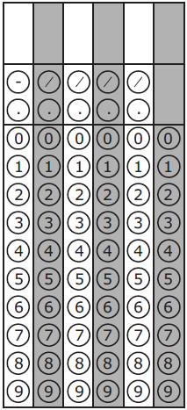



1. 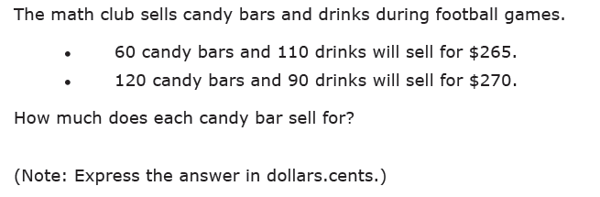





1. 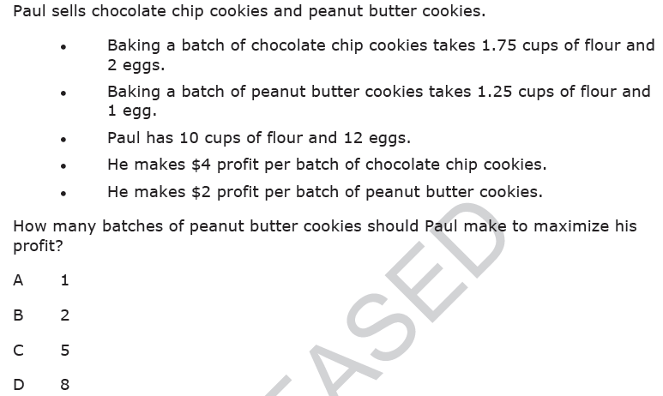





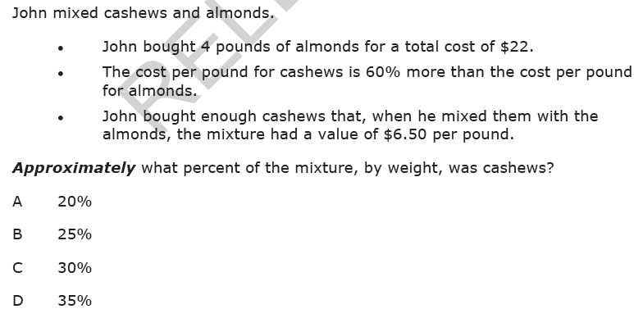

1. 

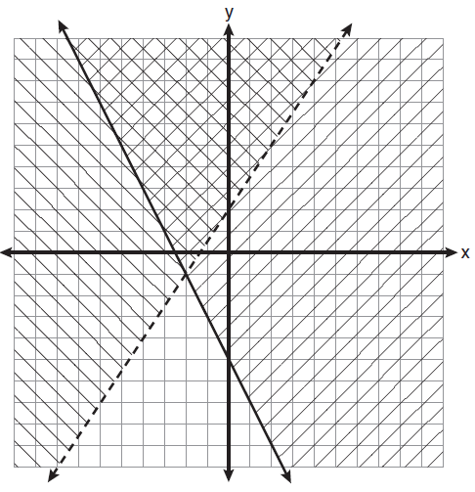

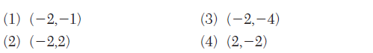

1. Which is the graph of the solution set of the system of inequalities? 



1. 