- What is the Next and Now that describes the sequence? -3, 1, 5, 9, …
  - $NEXT=NOW ∙(-3)$
  - $NEXT=NOW-3$
  - $NEXT=NOW+3$
  - $NEXT=NOW+4$

- Define the explicit form given table of a carnival game:
Number (n) of balls thrown | Total cost
1 | $5.00
2 | $6.50
3 | $8.00
4 | $9.50
  - $C=5n$
  - $C=5+\left(n-1\right)∙(1.50)$
  - $C=2n+5$
  - $C=1.5n+5$

- Given the two way table, choose which statement below is false.
 | Number of siblings
 | 0 | 1 | 2 | total
Girls | 5 | 10 | 12 | 27
Boys | 7 | 13 | 9 | 29
total | 12 | 23 | 21 | 56
  - The number of boys in the survey is more than the number of students with two siblings.
  - Ten percent of students that are girls have one sibling.
  - The percent of only children that are boys is about 58%.
  - The percent of girls in the survey is about 48%.

- Given the relative frequency table, which statement below is true if there are 80 students who took the test total?
 | English Test
 | Class 1 | Class 2 | Class 3 | total
Passed | .3 | .35 | .25 | .9
Failed | .0 | .05 | .05 | .1
total | .3 | .4 | .3 | 1.0
  - Five students from class 3 failed the test.
  - 28 students from class 2 passed the test.
  - 90 students passed the test total.
  - 4 students are in class 2.
- Given the table below, what percent of students were more than 5 points away from their predicted average from the line of best fit?
Name | Study Time | Actual Score on Test
Sarah | 40 minutes | 95
Joel | 10 minutes | 60
Gabby | 20 minutes | 72
Lawrence | 65 minutes | 100
Robert | 42 minutes | 85
  - 20%
  - 25%
  - 35%
  - 40%
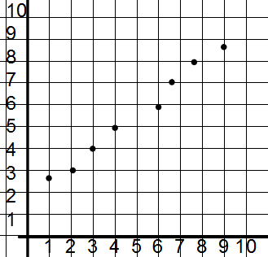
- What statement properly describes that scatter plot below?

  - The graph displays a strong negative correlation.
  - The graph displays a strong positive correlation.
  - The graph displays a weak negative correlation.
  - The graph displays a weak positive correlation.

- What statement is NOT true comparing the two box and whisker plots?
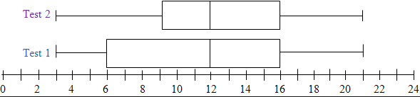
  - Both Box and Whisker plots have a minimum at 3.
  - The median of Test one is 12.
  - The first quartile of Test 1 is higher than the first quartile of Test 2.
  - The third quartiles are the same for both graphs.
- What is the approximate perimeter of the triangle with the given vertices A(-1, 3), B(3, 1), and C(1 , -3).
  - 15 units
  - 18 units
  - 20 units
  - 25 units

- If B is the midpoint between points A(1, 4) and C(3, 8) and E is the midpoint between points D(3, -1) and F(5, 1) what is the approximate distance of BE?
  - 4 units
  - 5 units
  - 6 units
  - 7 units
- A rectangle has an area of ${16x}^{2}-1$. What is a possible side length?
  - 4x - 1
  - 4x² + 1
  - 16x -1
  - 1 - 4x
- A cylinder has a diameter of 8 inches and a height of 10 inches, what is the volume rounded to the nearest tenth?
  - 499.3 in²
  - 502.7 in²
  - 2010.6 in²
  - 402.1 in²

