- Find the x-intercept and y-intercept in the following equation.
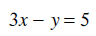

__________________________________________________________________________________________________
I: 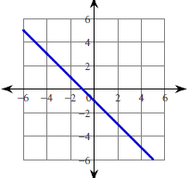
11. Find the x-intercept and y-intercept in the following equation.

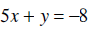

__________________________________________________________________________________________________
T: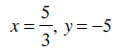
- Find the x-intercept and y-intercept in the following equation.

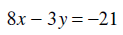

__________________________________________________________________________________________________
E: 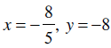
12. Find the x-intercept and y-intercept in the following equation.

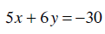

__________________________________________________________________________________________________
A: 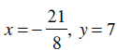
- Find the x-intercept and y-intercept in the following equation.

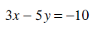

__________________________________________________________________________________________________
S: 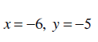
13. Write each equation in slope-intercept form.

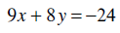

__________________________________________________________________________________________________
D: 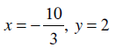
- Write each equation in slope-intercept form.
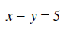

__________________________________________________________________________________________________
D: 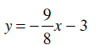
14. Write each equation in slope-intercept form.

__________________________________________________________________________________________________
M: 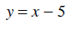
- Write each equation in slope-intercept form.
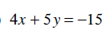

__________________________________________________________________________________________________
T: 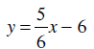
15. Write each equation in slope-intercept form.
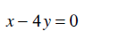

__________________________________________________________________________________________________
A: 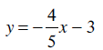
- Write each equation in slope-intercept form.
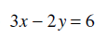

__________________________________________________________________________________________________
R: 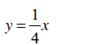
16. Write each equation in slope-intercept form.
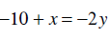

__________________________________________________________________________________________________
!: 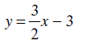
- Write each equation in slope-intercept form.
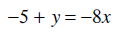

__________________________________________________________________________________________________
O: 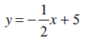
17. Write each equation in slope-intercept form.
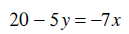

__________________________________________________________________________________________________
S: 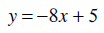
- Sketch the graph of each line. Find the x- and y-intercepts first.
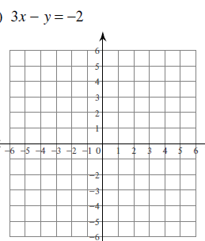

__________________________________________________________________________________________________
A: 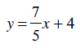
18. Sketch the graph of each line. Find the x- and y-intercepts first.
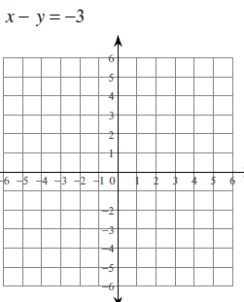

__________________________________________________________________________________________________
G: 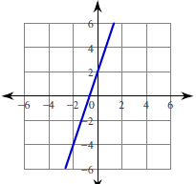
- Sketch the graph of each line. Find the x- and y-intercepts first.
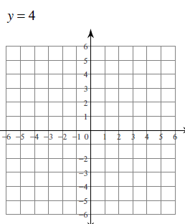

__________________________________________________________________________________________________
R: 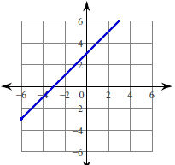
19. Sketch the graph of each line. Find the x- and y-intercepts first.
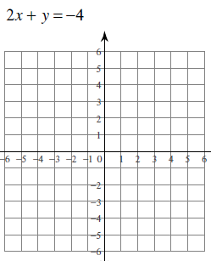

__________________________________________________________________________________________________
N: 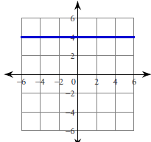
- Sketch the graph of each line. Find the x- and y-intercepts first.
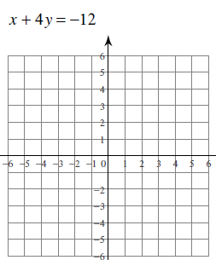

__________________________________________________________________________________________________
R: 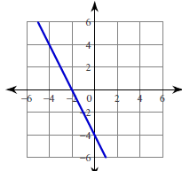
20. Sketch the graph of each line. Find the x- and y-intercepts first.
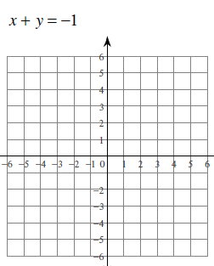

__________________________________________________________________________________________________
F: 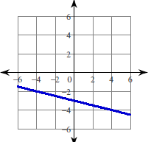

$$\frac{S}{12}\frac{T}{1}\frac{A}{17}\frac{N}{9}\frac{D}{13}\frac{A}{2}\frac{R}{15}\frac{D}{3}$$

$\frac{F}{10}\frac{O}{16}\frac{R}{19}\frac{M}{4}$ $\frac{I}{20}\frac{S}{7}$

$$\frac{G}{8}\frac{R}{18}\frac{E}{11}\frac{A}{5}\frac{T}{14}\frac{!}{6}$$

