Math 1 **Linear Programming (Day 2)** Unit 3

*SWBAT write and graph linear inequalities to model real-life situations to maximize an objective function.*

**Objective Function:**

**Steps to Solving a Linear Programming System of Inequalities**

**Step 1:** Define your variables

**Step 2:** Organize your information

**Step 3:** Write the inequalities

**Step 4:** Set up the objective function (maximize or minimize)

**Step 5:** Graph inequalities

**Step 6:** Find the vertices

**Step 7:** Plug vertices back into objective function

**Step 8:** Answer the question

**Example 1:** Susan is baking cakes and pies for a fundraiser. Susan is confident that she will be able to sell all the cakes and pies that she makes. There are *two constraints* that limit her production today:

**SUGAR:** Each cake requires 5 cups of sugar. Each pie requires 3 cups of sugar. Susan has 30 cups of flour total.

**EGGS:** Each cake requires 2 eggs. Each pie requires 3 eggs. Susan has 24 eggs total.

Write two inequalities. Then, find the intersection of these inequalities to show all combinations of cakes and pies that Susan can make with the two constrains given.

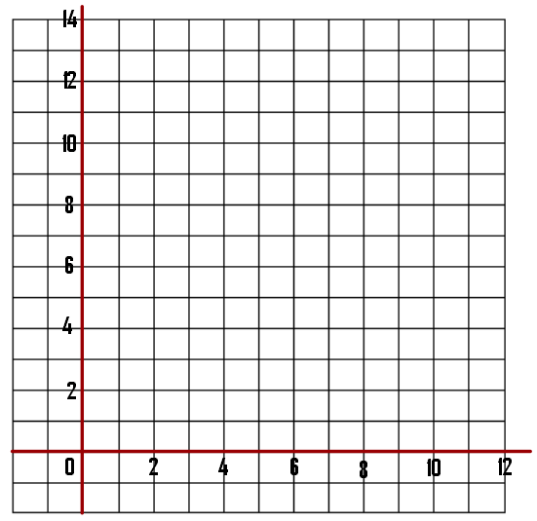

Let x = ________________________________________

y = ________________________________________

Inequality #1: __________________________________

X-intercept: _______ Y-intercept: _______

Inequality #2: __________________________________

X-intercept: _______ Y-intercept: _______

Suppose each cake makes a profit of $3.50 and each pie makes a profit of $4. How many cakes and pies should Susan make in order to maximize her profit?

**Objective Function:** ______________________________________________

Vertex 1: _______________ = ____________________________________________ = _______________

Vertex 2: _______________ = ____________________________________________ = _______________

Vertex 3: _______________ = ____________________________________________ = _______________

Vertex 4: _______________ = ____________________________________________ = _______________

Solution: ____________________________________________________________________________________________________________

**The Box Bakery**

Jack and Jill Box own a small bakery that makes fresh cookies daily. They bake two kinds of cookies – plain cookies and cookies with icing. The cookies are sold by the box, and Jack and Jill are confident they can sell all the cookies they make. However, there are three constraints that limit their production today:

**DOUGH:** One box of plain cookies requires 1.2 pounds of cookie dough.

One box of iced cookies requires 0.9 pounds of cookie dough.

Jack and Jill have 72 pounds of cookie dough.

**ICING:** Plain cookies require no icing.

One box of iced cookies requires 0.4 pounds of icing.

Jack and Jill have 20 pounds of icing.

**TIME:** One box of plain cookies requires about 0.1 hour to prepare.

One box of iced cookies requires about 0.15 hour to prepare.

Jack and Jill together have 9 hours for preparation.

Write three inequalities. Then, find the intersection of these inequalities to show all combinations of cookies that Jack and Jill can make with the constraints given.

Let x = ________________________________________

y = ________________________________________



Inequality #1: __________________________________

X-intercept: _______ Y-intercept: _______

Inequality #2: __________________________________

X-intercept: _______ Y-intercept: _______

Inequality #3: __________________________________

X-intercept: _______ Y-intercept: _______

Suppose the profit on each box of plain cookies is $2.00 and the profit on each box of iced cookies is $3.00. How many boxes of each kind of cookie should jack and Jill make to maximize profit?

**Objective Function:** ______________________________________________

Vertex 1: __________ = ____________________________________________ = _______________

Vertex 2: __________ = ____________________________________________ = _______________

Vertex 3: __________ = ____________________________________________ = _______________

Vertex 4: __________ = ____________________________________________ = _______________

Solution: _______________________________________________________________________________________________________________