**Geometry: EOC Prep** Name: ___________________________

Spring 2013

**Directions:** The following questions are sample items similar to those found on the EOC Exam. Answer each to the best of your ability.



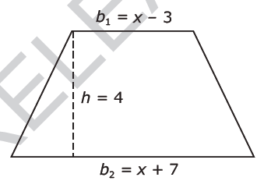

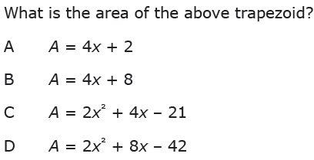

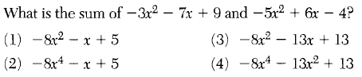

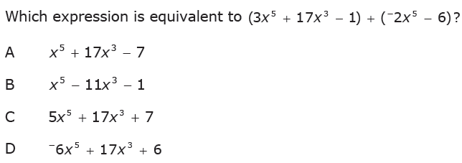

1. 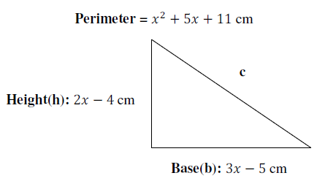Find the length of the missing side of the triangle below.

1. 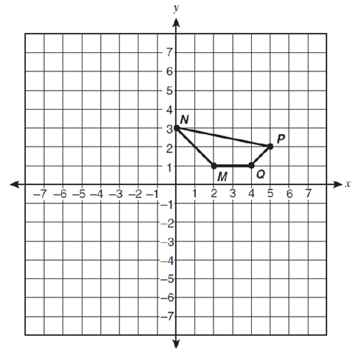 ***Approximate*** the length of the perimeter of the quadrilateral below.

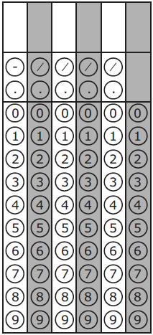

1. 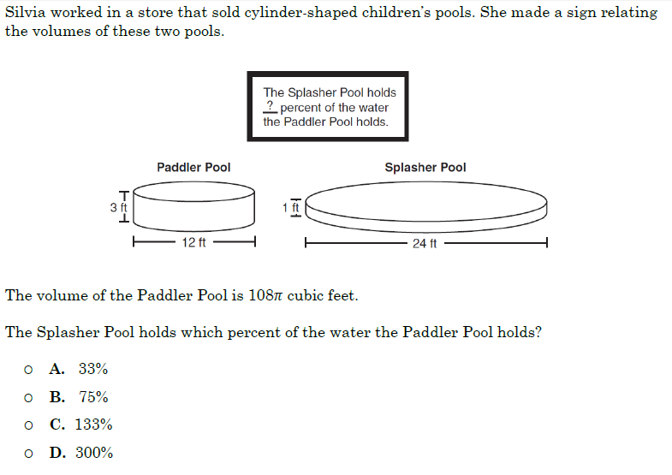

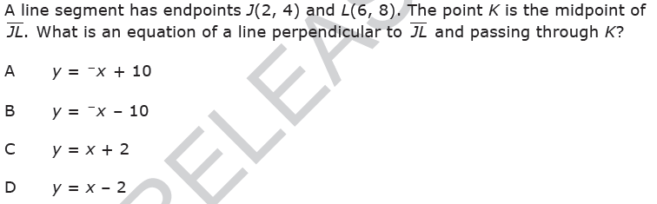

2. 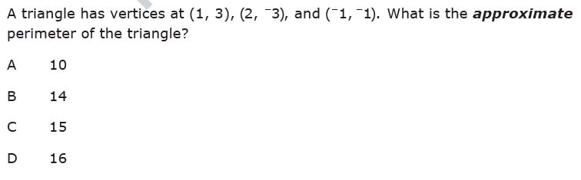

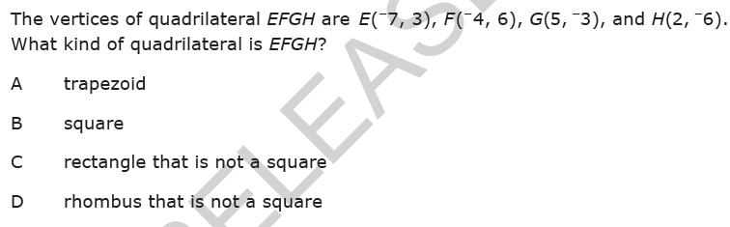







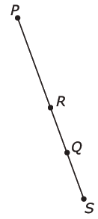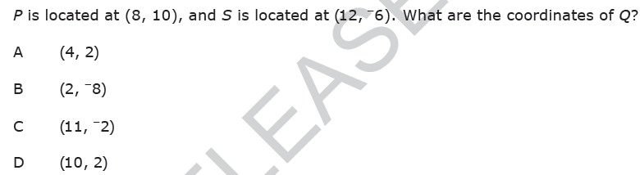

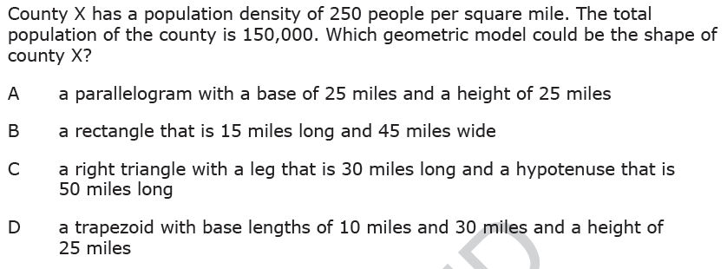



1. 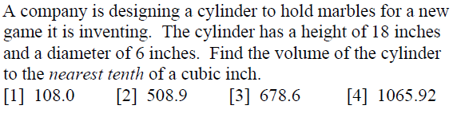
2. 