Geometry Word Problems Name: ___________________________
The geometry problems in this set involve lines, angles, triangles, rectangles, squares, and circles. You will learn how to find length, perimeter, area, circumference, and volume, and how you can apply geometry to everyday problems.
- A water sprinkler sprays in a circular pattern a distance of 10 ft. What is the circumference of the spray? (π = 3.14)

  - 31.4 ft
  - 314 ft
  - 62.8 ft
  - 628 ft

- If a triangular sail has a vertical height of 83 ft and horizontal length of 40 ft, what is the area of the sail?

  - 1,660 ft²
  - 1,155 ft²
  - 201 ft²
  - 3,320 ft²

- What is the volume of a ball whose radius is 4 inches? Round to the nearest inch. (π = 3.14)

  - 201 in³
  - 268 in³
  - 804 in³
  - 33 in³

- If a tabletop has a diameter of 42 in, what is its surface area to the nearest inch? (π = 3.14)

  - 1,384 in²
  - 1,319 in²
  - 1,385 in²
  - 5,539 in²

- An orange has a radius of 1.5 inches. Find the volume of one orange. (π = 3.14)

  - 9.42 in³
  - 113.04 in³
  - 28.26 in³
  - 14.13 in³

- A fire and rescue squad places a 15 ft ladder against a burning building. If the ladder is 9 ft from the base of the building, how far up the building will the ladder reach?

  - 8 ft
  - 10 ft
  - 12 ft
  - 14 ft

- Safe deposit boxes are rented at the bank. The dimensions of a box are 22 in by 5 in by 5 in. What is the volume of the box?

  - 220 in³
  - 550 in³
  - 490 in³
  - 360 in³

- **How many degrees does a minute hand move in 25 minutes?

  - 25°
  - 150°
  - 60°
  - 175°

- Two planes leave the airport at the same time. Minutes later, plane A is 70 miles due north of the airport and plane B is 168 miles due east of the airport. How far apart are the two airplanes?

  - 182 miles
  - 119 miles
  - 163.8 miles
  - 238 miles

- If the area of a small pizza is 78.5 in², what size pizza box would best fit the small pizza? (Note: Pizza boxes are measured according to the length of one side.)

  - 12 in
  - 11 in
  - 9 in
  - 10 in

- A rectangular field is to be fenced in completely. The width is 28 yd and the total area is 1,960 yd². What is the length of the field?

  - 1,932 yd
  - 70 yd
  - 31 yd
  - 473 yd

- Stuckeyburg is a small town in rural America. Use the map to approximate the area of the town.

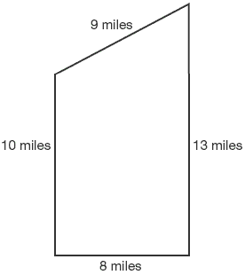
  - 40 miles²
  - 104 miles²
  - 93.5 miles²
  - 92 miles²

- A circular print is being matted in a square frame. If the frame is 18 in by 18 in, and the radius of the print is 7 in, what is the area of the matting? (π = 3.14)

  - 477.86 in²
  - 170.14 in²
  - 280.04 in²
  - 288 in²

- **Ribbon is wrapped around a rectangular box that is 10 in by 8 in by 4 in. Using the illustration provided, determine how much ribbon is needed to wrap the box. Assume the amount of ribbon does not include a knot or bow.
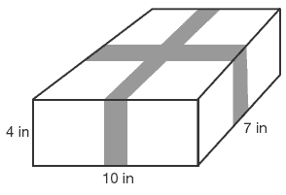
  - 50 in
  - 42 in
  - 22 in
  - 280 in

- *Pat is making a Christmas tree skirt. She needs to know how much fabric to buy. Using the illustration provided, determine the area of the skirt to the nearest foot.
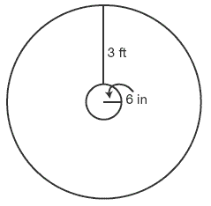
  - 37.7 ft²
  - 27 ft²
  - 75 ft²
  - 38 ft²

Answers
The following explanations show one way in which each problem can be solved. You may have another method for solving these problems.
- c. The circumference of a circle is π d. Since 10 ft represents the radius, the diameter is 20 feet. The diameter of a circle is twice the radius. Therefore, the circumference is (3.14)(20) or 62.8 ft. If you chose a, you used π r rather than 2π r. If you chose b, you found the area rather than circumference.
- a. The area of a triangle is (base)(height). Using the dimensions given, area = (40)(83) or 1,660 ft². If you chose d, you omitted from the formula.
- b. The volume of a sphere is π r³. Using the dimensions given, volume = (3.14)(4)³ or 267.9. Rounding this answer to the nearest inch is 268 in³. If you chose a, you found the surface area rather than volume. If you chose c, you miscalculated surface area by using the diameter.
- c. The area of a circle is π r². The diameter = 42 in, radius = 42 ÷ 2 = 21 in, so (3.14)(21)² = 1,384.74 in². Rounding to the nearest inch, the answer is 1,385 in². If you chose a, you rounded the final answer incorrectly. If you chose d, you used the diameter rather than the radius.
- d. To find the volume of a sphere, use the formula Volume = π r³. Volume = (3.14)(1.5)³ = 14.13 in³. If you chose a, you squared the radius instead of cubing the radius. If you chose b, you cubed the diameter instead of the radius. If you chose c, you found the surface area of the sphere, not the volume.
- c. The ladder forms a right triangle with the building. The length of the ladder is the hypotenuse and the distance from the base of the building is a leg. The question asks you to solve for the remaining leg of the triangle, or how far up the building the ladder will reach. Using the Pythagorean theorem: 92 + b² = 152; 81 + b² = 225; 81 + b² – 81 = 225 – 81; b² = 144; b = 12.
- b. The volume of a rectangular solid is length times width times depth. Using the dimensions in the question, volume = (22)(5)(5) or 550 in³. If you chose c, you found the surface area of the box.
- b. A minute hand moves 180 degrees in 30 minutes. Using the following proportion: . Cross-multiply, 30x = 4,500. Solve for x; x = 150 degrees.
- a. The planes are traveling perpendicular to each other. The course they are traveling forms the legs of a right triangle. The question requires us to find the distance between the planes or the length of the hypotenuse. Using the Pythagorean theorem 70² + 168² = c²; 4,900 + 28,224 = c²; 33,124 = c²; c = 182 miles. If you chose c, you assigned the hypotenuse the value of 168 miles and solved for a leg rather than the hypotenuse. If you chose d, you added the legs together rather than using the Pythagorean theorem.
- d. The area of a small pizza is 78.5 in². The question requires us to find the diameter of the pizza in order to select the most appropriate box. Area is equal to π r². Therefore, 78.5 = π r²; divide by π (3.14); 78.5 ÷ 3.14 = π r² ÷ 3.14; 25 = r²; 5 = r. The diameter is twice the radius or 10 inches. Therefore, the box is also 10 inches.
- d. The area of Stuckeyburg can be found by dividing the region into a rectangle and a triangle. Find the area of the rectangle (A = lw) and add the area of the triangle (bh) for the total area of the region. Referring to the diagram, the area of the rectangle is (10)(8) = 80 miles². The area of the triangle is (8)(3) = 12 miles². The sum of the two regions is 80 miles² + 12 miles² = 92 miles². If you chose a, you found the perimeter. If you chose b, you found the area of the rectangular region but did not include the triangular region.
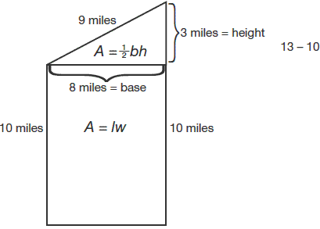
- b. The area of a rectangle is length times width. Using the formula 1,960 yd² = (l)(28), solve for l by dividing both sides by 28; l = 70 yards.
- b. To find the area of the matting, subtract the area of the print from the area of the frame. The area of the print is found using π r² or (3.14)(7)² which equals 153.86 in². The area of the frame is length of side times length of side or (18)(18), which equals 324 in². The difference, 324 in² – 153.86 in² or 170.14 in², is the area of the matting. If you chose c , you mistakenly used the formula for the circumference of a circle, 2π r, instead of the area of a circle, π r².
- a. The ribbon will travel the length (10 in) twice, the width (7 in) twice and the height (4 in) four times. Adding up these distances will determine the total amount of ribbon needed. 10 in + 10 in + 7 in + 7 in + 4 in + 4 in + 4 in + 4 in = 50 inches of ribbon. If you chose b, you missed two sides of 4 inches. If you chose d, you calculated the volume of the box.
- d. To find the area of the skirt, find the area of the outer circle minus the area of the inner circle. The area of the outer circle is π (3.5)² or 38.465 in². The area of the inner circle is π (.5)² or .785 in². The difference is 38.465 – .785 or 37.68 ft². The answer, rounded to the nearest foot, is 38 ft2. If you chose a, you rounded to the nearest tenth of a foot. If you chose b, you miscalculated the radius of the outer circle as being 3 feet instead of 3.5 feet.

