Math 1 **Geometry Application** Unit 6

*SWBAT apply geometric formulas to solve real-life application problems.*

|  |  |  |  |
| --- | --- | --- | --- |
| **Area Formulas:** | | **Volume Formulas:** | |
| **Circle** |  | **Rectangular Prism**  **(box)** |  |
| **Square** |  | **Cylinder**  **(can)** |  |
| **Rectangle** |  | **Cone** |  |
| **Triangle** |  | **Sphere**  **(ball)** |  |
| **Trapezoid** |  |  |  |

1. The volume of a sphere is 1,600 cubic centimeters. What is the approximate length of the diameter? (Volume of a sphere = .

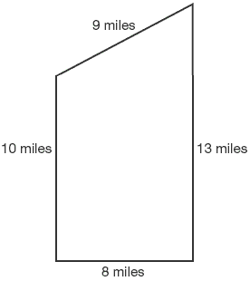

1. Stuckeyburg is a small town in rural America. Use the map to approximate the area of the town.
   1. 40 miles2
   2. 104 miles2
   3. 93.5 miles2
   4. 92 miles2
2. The volume of a cone can be found using the formula , where B is the area of the base of the cone and h is the height. A cone has a volume of 262 cubic inches and a height of 10 inches. What is the approximate length of the radius of the cone rounded to the nearest inch?

**Coordinate Geometry!**

1. A quadrilateral has vertices located at (-3, -5), (4, 2), (4, 1), and (2, -1). Which of the following best describes the figure?
2. A quadrilateral has vertices at (-8, 0), (-4, -4), (0, 8) and (4, 4). What is the area of the quadrilateral?

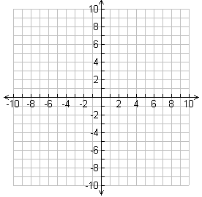

1. Rhombus
2. Rectangle
3. Trapezoid
4. Square

1. Which term best describes the triangle shown?

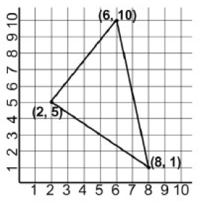

* 1. Equilateral
  2. Right
  3. Scalene
  4. Isosceles

1. A triangle has vertices of (1, 2), (3, 1), and (-2, -1). What is the perimeter of the triangle, rounded to the nearest unit?

