Functions Review Sheet Name _________________________
- Given the following patterns, finish each table and write the function rule:
X | 1 | 2 | 3 | 4 |  | n
Y | 1 | 3 | 5 |  | 19

X | 0 | 1 | 2 | 3 |  | n
Y | 3 | 6 | 9 | 12 | 21

- Make a table and graph the following function:
y = 3x + 2

- List the domain and range of each relation:
{(2,3) (3,4) (3,5) (4,9) (-1,2)} D:________________ R:___________________Is this a function?_______
{(1,4) (2,4) (7,3) (-1,4) (-2,-2)} D:_______________ R:___________________Is this a function?________
- Find the range for y = 4x – 3 if the domain is {-4, 0, 1, 2}

- Determine if the following is a linear function? Why or why not? If it is linear, write the function rule (equation).
x | y
1 | 6
2 | 8
3 | 10
4 | 12
x | y
1 | 3
2 | 9
3 | 27
4 | 81

- Write a function rule for the following: The cost c if a plumber charges $89 for a house call plus $50 per hour to repair a sink

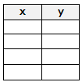
- Write the following in a table and then determine the domain and the range:
(-4, 6) (3, 8) (2, 4) (1, 3)
    - Domain_____________________
    - Range______________________

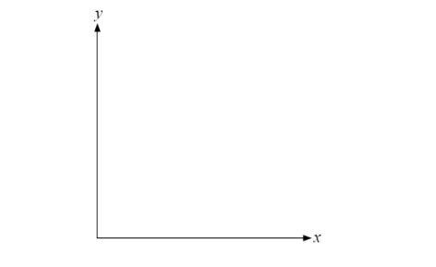
- After work, Jan walks slowly toward her home, but stops at a McDonald’s to get a cup of coffee. After 15 minutes, Jan continues walking home. Let the x-axis be time, and the y-axis be the distance from home.
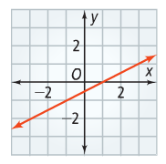
- Is the graph below a function? Why or why not?

- Find each value for f(x) = 3x -3

- f (2)
- f(-4)

- Find each value for g(x) : 2x² + x

- g(-2)
- g(4)

- Complete a table and graph using any value for x, y = 2x +2

