Standard 8.EE.1 **7.3 Multiplying Powers** Unit 5

|  |  |  |
| --- | --- | --- |
| **Multiplying Powers with the Same Base** | | |
| To multiply powers with the same base, add the exponents. |  | Examples: |

**Why it Works:** Use repeated multiplication to rewrite the product of powers: 24 x 23 = ?

1. Expand each into the product numbers below.

24  x 23 = ?

( ) x ( ) =

**Multiplying Powers**

What is each expression written using each base only once?

1. 
2. 
3. 
4. 
5. 
6. 

**Multiplying Powers in Algebraic Expressions**

What is the simplified form of each expression?

1. 
2. 

Got it? What is the simplified form of each expression in the following parts?

1. 
2. 
3. 
4. Explain how to simplify the expression

**Finding the Area of Geometric Figures**

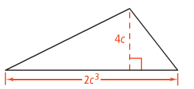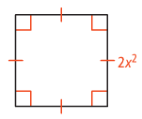Find the area of each of the following.