Foundations of Math 1 5.4 Point-Slope Form Unit 6 Day 3

Point Slope Form: An equation of a nonvertical line with slope m and through point (x₁, y₁)
(y – y₁) = m(x – x₁)

Writing an Equation in Point-Slope Form
- A line passes through (-3, 6) and has slope -5. What is an equation of the line?

- A line passes through (8, -4) and has a slope of 2/3. What is an equation in point-slope form of the line?

Graphing Using Point-Slope Form

- What is the graph of the equation:
$$y-1=\frac{2}{3}(x-2)$$
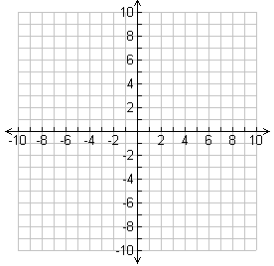
- What is the graph of the equation:
$y+7=-\frac{4}{5}(x-4)$

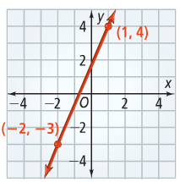
Using Two Points to Write an Equation
What is the equation of the line to the right?

Using a Table to Write an Equation
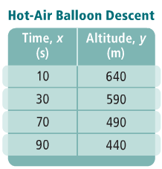
The table shows the altitude of a hot0air balloon during its linear descent. What equation in slope-intercept form gives the balloon’s altitude at any time? What do the slope and y-intercept represent?

