Foundations of Math 1 4.6 Relations and Functions Unit 5 Day 5

Lesson Vocabulary
Relation: A set of _____________ ____________. It can be written as ______________, _______________, or a _____________.
Domain: The set of _______ values in an ordered pair.
Range: The set of _______ values in an ordered pair.
Function: A relation in which every x value has only one y value. The X’s can’t ________________!!!!!
Vertical Line Test: A way to test if a graph is a function or not.
Function Notation: To write a rule in function notation, you use the symbol ________ instead of _____. It is read “F of X”

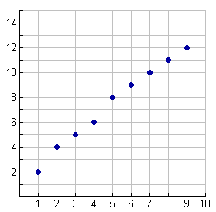
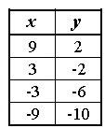
Identifying Domain and Range
List the domain and range for each relation.

- (4, 0) (2, 8) (6, -1) (10, 4)

Identifying Functions by Comparing X-Values
Are the following relations functions? Compare the x-values by setting up a table.
- (2, 4) (3, 5) (5, 10) (2, 7)
- (1, 1) (2, 2) (3, 3) (4, 4) (5, 5)

Identifying Functions Using the Vertical Line Test
Drop a straight line through the graph. If it touches it twice, it is not a function!

Evaluating a Function
Step 1: Substitute the number inside f( ) into the equation for x.
Step 2: Simplify the equation.
Step 3: Rewrite as a solution set.

Evaluate each of the following.

- f(x) = 3x + 4 for f(2)
- f(x) = 3x + 4 for f(6)
- f(x) = -12x + 1 for f(-3)

Finding the Range of a Function
Step 1: Substitute each value of the domain into the equation separately.
Step 2: Simplify each equation separately.
Step 3: Write your solutions in a solution set.

- The domain of f(x) = 2x + 12 is {-2, -1, 0, 1, 2}. What is the range?

- The domain of g(x) = –4x – 12 is {1, 3, 5, 7}. What is the range?

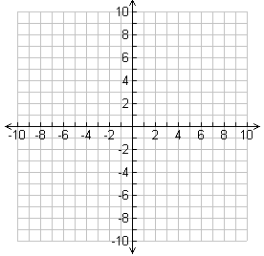
Lesson Check: Do you know how?

- Use the relation {(-2, 3), (-1, 4), (0, 5), (1, 6)} to answer the following questions.
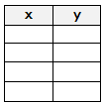
  - Identify the domain and range of the relation.
  - Represent the relation as a graph and as a table.
  - Is the relation a function?

Domain:

Range:

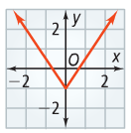
- Is the graph to the left a function? Use the vertical line test.

- What is f(2) for the function f(x) = 4x + 1?

- The domain of f(x) = ½x is {-4, -2, 0, 2, 4}. What is the range?

