Foundations of Math 1 4.4 Graphing a Function Rule Unit 5 Day 4
SWBAT graph equations that represent functions.

When graphing functions, we first need to create a table of values. You should have at least 3 x-values and 3 y-values generated in your table before you graph. After that, we can plot our new ordered pairs to create a line.

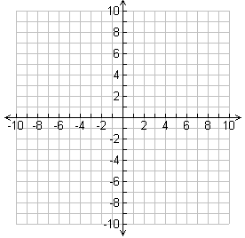
Graphing a Function Rule
What is the graph of the function rule y = 2x + 1?
x | y = 2x + 1 | Ordered Pair (x, y)

What is the graph of the function rule y = ½x – 1?
x | y = ½x – 1 | Ordered Pair (x, y)

Graphing real-world Function Rules
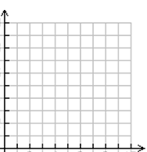
The function rule W = 8g + 700 represents the total weight W, in pounds, of a spa that contains g gallons of water. What is a reasonable graph of the function rule, give that the capacity of the spa is 250 gallons?
g | W = 8g + 700 | Ordered Pair (x, y)

Foundations of Math 1 4.5 Writing a Function Rule Unit 5 Day 4
SWBAT write equations that represent functions.

Writing a Function Rule
You can estimate the temperature by counting the number of chirps of the snowy tree cricket. The outdoor temperature is about 40 degrees more than one fourth of the number of chirps the cricket makes in one minute. What is a function rule that represents this situation?

Step 1: Relate is more than of

Step 2: Define Let = the temperature. Let = the number of chirps in 1 minute.

Step 3: Write

Write a function rule to represent each function.
- The total cost C for p pounds of copper if each pound costs $3.57.

- The height f, in feet, of an object when you know the object’s height h in inches.

- The amount y of your friend’s allowance if the amount she receives is $2 more than the amount x you receive.

- Challenge: The volume V of a cube-shaped box whose edge lengths are 1 inch greater than the diameter d of the ball that the box will hold.

Writing and Evaluating a Function Rule
A kennel charges $15 per day to board dogs. Upon arrival, each dog must have a flea bath that costs $12.
- Write a function rule for the total cost of n days of boarding plus a bath.

- How much does a 10-day stay cost?

