Foundations of Math 1 **4.3 Patterns and Nonlinear Functions** Unit 5 Day 3

*SWBAT identify and represent patterns that describe nonlinear functions*

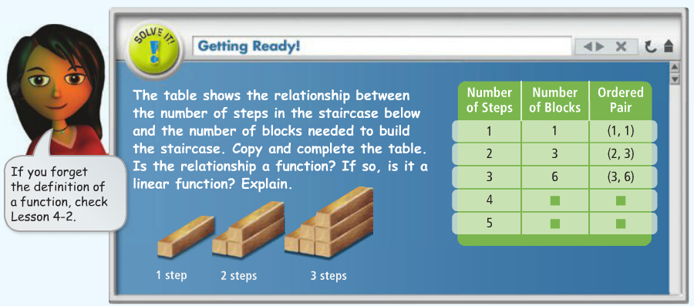

Complete the table to the left for the pattern indicated with the blocks.

1. What is the independent variable?
2. What is the dependent variable?
3. Graph the ordered pairs. What do you notice about the shape of the scatterplot?

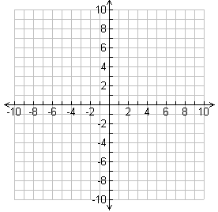

1. Is the relationship a function (do the x-values repeat)?

1. Is it linear?
2. See if you can find the equation that would fit this situation. Then describe the relationship in words.

**Lesson Vocabulary**

**Linear Function:**

**Non-Linear Function:**

**Non-Linear Patterns**

Determine whether the relationship is a linear or non-linear function. Then, represent the relationship using words, an equation, and a graph.

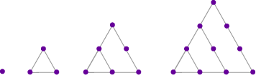

|  |  |  |  |  |  |  |
| --- | --- | --- | --- | --- | --- | --- |
| **Triangular Number** | 1 | 2 | 3 | 4 | 5 | 6 |
| **Dots** | 1 | 3 | 6 | 10 |  |  |

**Equation:**

**Classifying functions as Linear or Nonlinear**

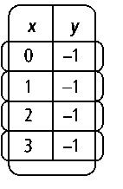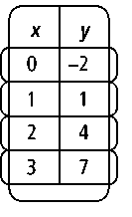Tell whether the function is linear or nonlinear and how you know.

1. 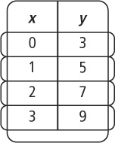
2. 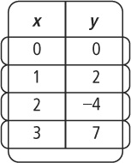

**Writing a Rule to Describe a Nonlinear Function**

Write a rule (equation) that represents each function below. Note any techniques that can be used to find non-linear equations.

1. (0, 1), (1, 3), (2, 9), (3, 27), (4, 81)
2. (0, 0), (1, 1), (2, 4), (3, 9), (4, 16)
3. (0, 1), (1, 0.5), (2, 0.25), (3, 0.125), (4, 0.0625)
4. (0, 0), (1, 1), (2, 8), (3, 27), (4, 64)

**Real-Life Applications**

The rule C = 6.3r gives the approximate circumference C of a circle as a function of its radius r. Identify the independent and dependent variables in this relationship. Explain your reasoning.

A landscape architect wants to make a triangular garden inside a square of land as shown at the right. What is a rule for the area A of the garden as a function of s?

