Foundations of Math 1 4.2 Patterns and Linear Functions Unit 5 Day 2

Dependent Variable:
Independent Variable:
Inputs:
Outputs:
Function:
Linear Function:

Representing a Geometric Relationship
In the diagram below, what is the relationship between the number of rectangles and the perimeter of the figure they form? Represent this relationship using table, words, an equation, and a graph.
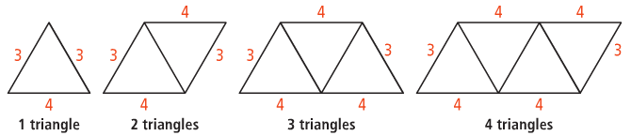
Words

Equation

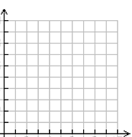

Number of Triangles (x) | Perimeter (y) | Ordered Pair (x, y)
1
2
3
4

Representing a Linear Function
The table shows the relationship between the number of photos you take, x, and the amount of memory in megabytes (MB), y, left on your camera’s memory chip. Is the relationship a linear function? Describe using words, an equation, and a graph.
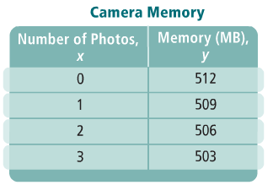
Words: Equation:
Memory is 512 MB before any pictures are taken.

The dependent variable y decreases by 3 each time x increases by 1
The independent variable x increases by 1 each time!

