Foundations of Math 1 4.1 Using Graphs to Relate to Two Quantities Unit 5 Day 1

Example 1: The following graph shows the distance traveled by a school bus based on every morning from 6:30-7am.
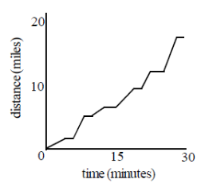
- What do the flat sections of the graph represent?

- What do the steep sections of the graph represent?

- Why doesn’t the path of the line ever go down?

Often you will need to recognize graphs plotting distance versus time, or distance from a point versus time, usually with the time plotted on the x-axis.

Distance is called a _________________________ of time.

Example 2: Match each graph below with the appropriate situation.
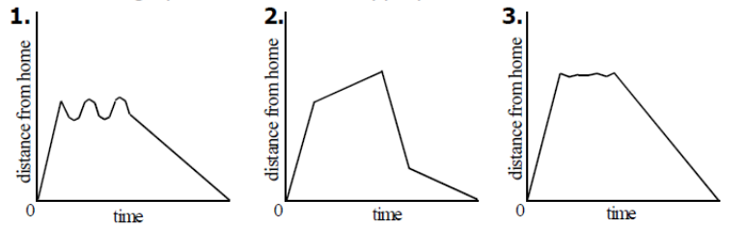
- Mary leaves the house, walks to the store, and returns with groceries.
- Roger walks around the block.
- Sylvia runs to the track, takes a few laps, and then runs home.

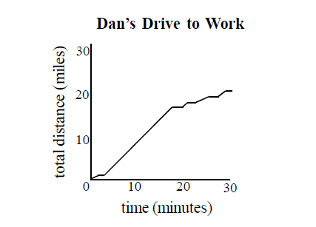
Example 3: Use the graph below to answer each of the following.
- When is Dan driving on the highway?

- Approximate Dan’s average speed for the trip to work.

- Approximate Dan’s top speed on his way to work.

Example 4: Use the graph below to answer each of the following.
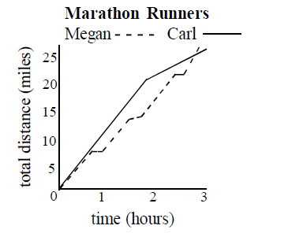
- Who finishes the marathon first?

- How do Megan and Carl’s strategies compare?

- Approximately how many minutes does it take Carl to run each mile during the first 1:40 of the race? (4, 5, 6, or 7 minutes?)

Example 5: Sketch a graph to model each of the following situations. Think about the shape of the graph and whether it should be a continuous line or not.

Situation A: Candle  Each hour a candle burns down the same amount.  X = the number of hours that have elapsed.  Y = the height of the candle in inches. | 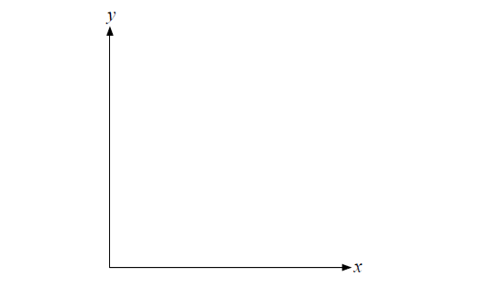
Situation B: Driving

When driving to grandma’s for Thanksgiving, you leave your house driving 25 mph. You increase your speed to 65 on the interstate, and then get off to stop at Subway for lunch. You get back on the interstate in heavy traffic, and have to drive 45 mph until you arrive at grandma’s house.

X = the time it takes to get to grandma’s

Y = the distance from your home

Situation C: Bus

A group of people rent a bus for the day. The total cost of the bus is shared equally among the passengers.

X = the number of passengers

Y = the cost for each passenger in dollars

Situation D: Car Value

My car loses about half of its value each year.

X = the time that has elapsed in years

Y = the value of my car in dollars

