Standard A.REI.3 **3.4 Solving Multi-Step Inequalities** Unit 1 Day 6

**Inequalities:** A way of describing a _________________ or _________________ value.

* To solve inequalities, treat the problem as if it were a normal equation.
* Remember to _______ the symbol if multiplying or dividing by a _________________.

< > < >

|  |  |  |  |
| --- | --- | --- | --- |
| Open or Closed Circle:  Shade to the right or left? | Open or Closed Circle:  Shade to the right or left? | Open or Closed Circle:  Shade to the right or left? | Open or Closed Circle:  Shade to the right or left? |

**Example 1:** Solve for . Check your solutions.

**You Try!** What are the solutions of the inequality? Check your solutions.

1.  
2.  

**Example 2:** Solve for each solution.

1.  
2.  

**Compound Inequality:** A relationship of two distinct inequalities joined by the words ______ or ______.

|  |
| --- |
| **“AND”** Inequalities |
| * Two graphs ______________ or come together. |
|  |

|  |
| --- |
| **“OR”** Inequalities |
| * Two graphs shoot off in ____________ directions |
|  |

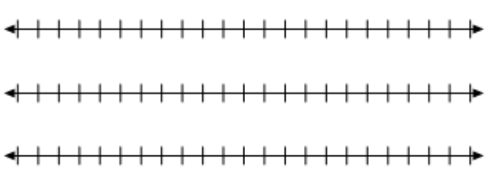**Example 3:** What are the solutions of ? Graph the solutions.

**You Try!** What are the solutions of ? Graph the solutions.

**Example 4:** What are the solutions ofor  ? Graph the solutions.



  
**Example 3:** What are the solutions ofor  ? Graph the solutions.