Math 1 12.2 Frequency and Histograms Unit 4
Frequency: The number of ______________ _______________ in an interval
Frequency Table: Groups a set of data values into intervals and shows the __________________ for each interval
- Frequency tables do not overlap, do not have any gaps, and are usually of equal size
Histogram: A graph that can display data from a _____________________ _______________.
Cumulative Frequency Tables: Shows the number of values that lie in or _______________ a given interval.

Making a Frequency Table
The numbers of home runs by the batters in a local home run derby are listed below. What is a frequency table that represents the data? 7, 17, 14, 2, 7, 9, 5, 12, 3, 10, 4, 12, 7, 15

Home Runs | Tally | Frequency
2-5
6-9
10-13
14-17

Making a Histogram
The data below are the numbers of hours per week a group of students spent watching television. What is a histogram that represents the data? 7, 10, 1, 5, 14, 22, 6, 8, 0, 11, 13, 3, 4, 14, 5

Step 1: Create a frequency table. Step 2: Construct a Histogram (bar graph)
Hours of TV | Frequency

Shapes of Histograms
You can describe histograms by their shape. Three different types are listed below.
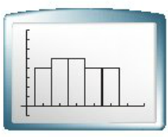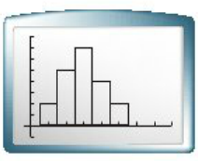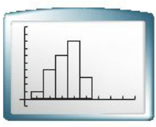

Making a Cumulative Frequency Table
The numbers of text messages sent on one day by different students are shown below. What is the cumulative frequency table that represents the data? 17, 3, 1, 30, 11, 7, 1, 5, 2, 39, 22, 13, 2, 0, 21, 1, 49, 41, 27, 2, 0

# of Texts
Frequency
Cummulative Frequency
Practice:
- The following data consists of the weights, in pounds, of 24 high school students:
195, 206, 100, 98, 150, 210, 195, 106, 195, 108, 180, 212, 104, 195, 100, 216, 99, 206, 116, 142, 100, 135, 98, 160
- Using this data, complete the accompanying cumulative frequency table and construct a frequency histogram on the grid below.

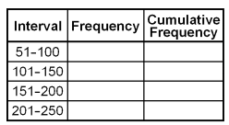

- The scores on a mathematics tests were 70, 55, 61, 80, 85, 72, 65, 40, 74, 68, and 84. Complete the accompanying table, and use the table to construct a frequency histogram for these scores.
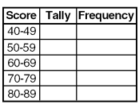

- The accompanying histogram shows the heights of the students in Kyra’s health class.
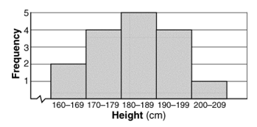
What is the total number of students in the class?

- 15
- 209
- 16
- 5

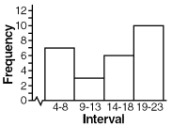
- Which one of the following histograms represents the data in the table below?

