Math 1 Distance and Midpoint Formulas Unit 6

Line Segment: Part of a line that has two endpoints. The line segment is named by these two endpoints.
Midpoint: The distance halfway between two points
Segment Bisector: A line that cuts a second line directly in half (located at the midpoint).

The Distance Formula | The Midpoint Formula

The Distance Formula
Find the distance between each of the following points.

- R(5, 1) and S(-3, -3)
- T(0, 0) and P(12, 8)

- A triangle has vertices at (1, 3), (2, -3) and (-1, -1). What is the approximate perimeter of the triangle? Draw a picture to help.

Discovering The Midpoint Formula: Find the midpoint between each of the following points.

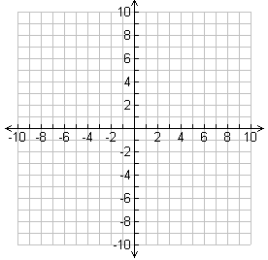
- E(-2, 6) and F(10, -8) – use the graph to the left.

- M(11, -2) and N(-9, 13)

- R is the midpoint of segment $\overline{PS}$. Q is the midpoint of segment $\overline{RS}$. P is located at (8, 10) and S is located at (12, -6). What are the coordinates of Q? Draw and label a picture to help.

Midpoint Formula: Working It Backwards

Split Formula in Two:
- Plug in what you know  - Solve for x₂ | - Plug in what you know  - Solve for x₂

Find the coordinates of C if B(4, 3) is the midpoint of AC and A is located at (6, -12).

Putting it Together
What is the approximate length of the segment $\overline{CD}$ if $\overline{CD}$bisects $\overline{AB}$ at C and A(3, 5), B(7, -3), and D(-4, 2)? Draw and label a picture to help.

