Math 3 9.6 Sampling Unit 9
SWBAT identify and apply methods of data collection for the purpose of statistical analysis.

For an event to be ________________, there is no predetermined pattern or bias toward any particular outcome.

Example 1: A class of 25 students wants to choose 3 students at random to bring food for a class party. Any set of 3 students would have an equal chance of being chosen. Which of the following strategies will result in a fair decision? Are these scenarios random? If not, explain.

- The students line up alphabetically, and each one in succession flips a fair coin. The first three students to flip heads bring the food.

- Each student draws a card from a well-shuffled deck of 52 cards. The teacher shuffles a second deck of cards, spreads them out, and draws cards one by one until he matches the cards of the three students.

Example 2: A random number table contains randomly-generated digits from 0 to 9. You can use these numbers to model randomness for sampling purposes.
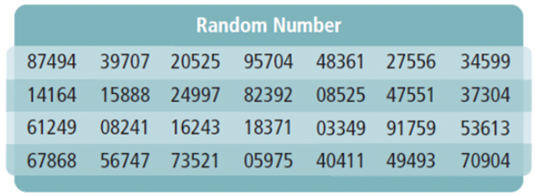
A coach wants to select 3 of her 15 basketball players at random to lead warm-ups before practice each week. The coach assigns each player a number 01 to 15. How can the coach use the random number table to fairly choose the three players?

Simulations and Probability Models

You can use a ______________________ to assign probabilities to outcomes of a chance process.

Example 3: Suppose that you are playing a board game for which you must roll a 6 on a number cube before you are able to move your game piece from start. Describe a simulation you can use to predict the number of times you would expect to have to roll the number cube before you can move from start.

Sampling Methods

Convenience Sample: Select any members of the population who are conveniently and readily available

Voluntary Response Sample: Select only members of the population who volunteer for the sample

Systematic Sample: Order the population and then select from it at regular intervals

Random Sample: All members of the population are equally likely to be chosen

Types of Studies

Observational: Members are observed or measured in such a way that they are not affected by the study.

Controlled Experiment: The sample is divided into two groups.
- A “treatment” is imposed on one group, but not on the control group.
- The effect of the “treatment” on the treatment is then compared to the control group.

Survey: Every member of the sample set is asked a set of questions

Bias: systematic error introduced by the sampling method.
EX: Only surveying a certain age group or excluding certain people with specific opinions

Example 4: What type of sampling method is used in each scenario? Is there any bias in each sample?

- A service surveys every 25th listing in a local directory.

- A reporter interviews people on the street in a large city.

- A radio station allows people to call in to give their answers to a survey.

Survey Questions
To create unbiased survey questions, avoid:
- Combining two or more issues, using double negatives, overlapping answer choices, words that cause strong reaction, leading the subject to an answer.

Example 5: Are the following questions bias? If they are, explain why.

- Do you think that the food and beverages being served in the cafeteria taste good?

- Don’t you agree that school days should be shorter?

- Do you prefer watching exciting movies or reading dull books?

