Math 3 9.5 Margin of Error Unit 9
SWBAT calculate the margin of error and the 95% confidence interval for entire and sample populations.
FORMULA: $ME=1.96(\frac{s}{\sqrt{n}})$

ME=
n=
S=

Margin of Error:

FORMULA:
$$\overline{x}-ME≤μ≤\overline{x}+ME$$
Where $\overline{x}$ is the sample mean and $μ$ is the population mean; the range is the confidence interval

Confidence Interval:

Example 1: A grocery store manager wanted to determine the wait times for customers in the express lines. He timed customers chosen at random.

- What is the mean and standard deviation of the sample? Round to the nearest tenth of a minute.

- At a 95% confidence level, what is the approximate margin of error? Round to the nearest tenth of a minute.

- What is the confidence interval for a 95% confidence level?

d) What is the meaning of the interval in terms of wait times for customers?
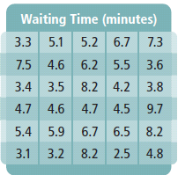

Sample Proportion: $\hat{p}$
Example 2: What is the sample proportion for each situation? Write the ratios as percents rounded to the nearest tenth of a percent.
a) In a poll of 1085 voters selected randomly, 564 favor Candidate A.

b) A coin is tossed 40 times, and it comes up heads 25 times.

Margin of Error for a sample proportion:
$$ME=1.96\sqrt{\frac{\hat{p}(1-\hat{p})}{n}}$$
Where $\hat{p}$ is the____________________________
and n is the __________________________
95% Confidence Interval for a
Population Proportion:

Example 3: Find the sample proportion, the margin of error, and the 95% confidence interval for the population proportion.

- In a survey of 530 randomly selected high school students, 280 preferred watching football to watching basketball.

- In a simple random sample of 500 people, 342 reported using social networking.

For Exercises 1-2, find the 95% confidence interval for the population mean or population proportion, and interpret the confidence interval in context.
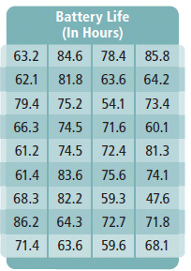
- A consumer research group tested the battery life of 36 randomly chosen batteries to establish the likely battery life for the population of the same type of battery.

- In a poll of 720 likely voters, 358 indicate they plan to vote for Candidate A.

