Math 3 9.3 Z-Scores Unit 9
SWBAT use the z-scores of a data set to find the percentage of data under the normal curve.

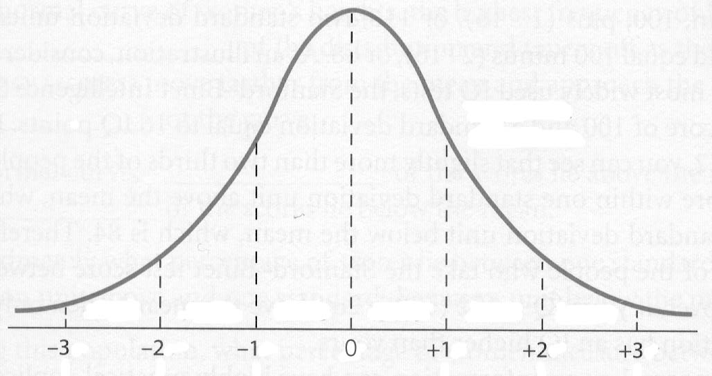
Z-Score: A statistical measurement of a score’s relationship to the mean of a group of scores. A Z-score of 0 means the score is the same as the mean. A Z-score can also be positive or negative, indicating whether it is above or below the mean and by how many standard deviations.

$$Z Score=\frac{ Raw Score-Mean }{Standard Deviation}$$

Symbols | Sample Population | Entire Population
Mean
Standard Deviation

Example 1: Suppose a normal distribution has a mean of 10 and a standard deviation of 2. Find the z-scores of the following measurements:

- 9
- 10
- 11
- 14

Example 2: Suppose a data set is represented by a normal distribution with a mean of 125 and a standard deviation of 7.
- What data value is 2 standard deviations above the mean?

- What data value is 3 standard deviations below the mean?

Example 3: In a normally distributed data set, find the value of the standard deviation if the following additional information is given.

- The mean is 22.6 and the z-score for a data value of 230 is 0.2.

- The mean is 9.8 and a z-score for the data value of 10.3 is 2.

ALWAYS SKETCH A NORMAL CURVE AND LABEL THE X-AXIS.
Example 1: A forest products company claims that the amount of usable lumber in its harvested trees averages 172 cubic feet and has a standard deviation of 12.4 cubic feet. Assume that these amounts have approximately a normal distribution.

How to find Proportions with Z-Scores
Step 1: | Draw a normal curve and label the x-axis.
Step 2: | Find the z-score corresponding to the value indicated in the question. Interpret this in terms of standard deviations away from the mean.
Step 3: | Hit 2nd-VARS-2: normalcdf(lower bound, upper bound). The answer is the proportion corresponding to your z-score. Write as a percentage.
Note: Use 9⁹⁹ for the upper bound if it is not already given.
Note: Use -9⁹⁹ for the lower bound it if is not already given.
- What proportion of trees contains more than 150 cubic feet?

- What proportion of trees contain between 175 and 190 cubic feet?

Example 2: Healthy 10-week-old domesticated kittens have average weight 24.5 oz. with a standard deviation of 5.25 oz. The distribution is approximately normal. A kitten is designated as dangerously underweight when, at 10 weeks, it weighs less than 10.0 oz. What proportion of kittens will designate as dangerously underweight?

You Try! Suppose that there are 100 franchises of Betty's Boutique in similar shopping malls across America. The gross Saturday sales of these boutiques are approximately normally distributed with a mean of $4610 and a standard deviation of $370.

- Draw a normal curve below and label the horizontal axis.
- Find the z-scores of each of the following gross Saturday sales amounts: $3870, $4425, and $5535.

- What percentage of Betty's Boutique franchises had gross Saturday sales between $4425 and $5535? Use the z-scores you found in part (a) and the normalcdf( function in the calculator.

- What percentage had gross Saturday sales between $3870 and $5535? Use the z-scores you found in part (a) and normalcdf function in the calculator.

- What percentage of stores had gross Saturday sales less than $5535?

