Math 3 9.2 Normal Distribution Unit 9
SWBAT graph the distribution of a normal bell curve.

Normal distribution: Has data that vary randomly about the mean; has a “normal curve,” also known as the bell curve.

Empirical Rule | 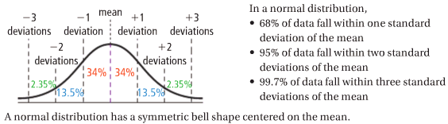

Example 1: The following normal distribution describes the repair times for a local auto shop. Answer the questions below:
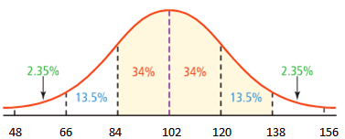
- What is the mean repair time for the auto shop?

- What percentage of repairs take between 84 and 120 minutes?

- What percentage of the repairs take less than 2 hours?

- What percentage of repairs are between 84 minutes and 138 minutes?

- If the shop did 200 repairs this week, approximately how many of them took more than 2 hours?

Example 2: Sketch a normal curve for the following distribution: mean = 45, standard deviation = 5

Example 3: In a set of test scores that are normally distributed, a test score of 70 is 3 standard deviations below the mean. A score of 86 is 1 standard deviation above the mean. What is the mean of the data?

