Math 3 9.1 Analyzing Data Unit 9
SWBAT find the measures of central tendency and the standard deviation of a set of data.
Central Tendency: Central values or “_______________” of a data set.

Mean: ______________ for a set of data.

Median: The middle value for a data set listed in order.

Mode: The _____________ frequently occurring values in a set of data.

Range: The ___________________ between the highest and lowest values in a set of data.

Outlier: The value that is ______________________ different from the rest of the data in a set.

Example 1: Find the mean, median, mode, and range. Identify any outliers:

- 3.4, 4.5, 2.3, 5.9, 9.8, 3.3, 2.1, 3.0, 2.9

- 17, 21, 19, 10, 15, 19, 14, 0, 11, 16

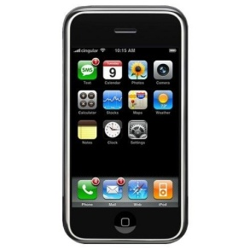

Finding Central Tendency: HOW MANY CALLS?
Directions: Determine how many calls you have made within the past two days. Record the class data in the space below.

- Find the range:

- Find the mean:

- Find the median:

- Find the mode:

- Outliers?

Example 3: You scored an 83%, 74%, 95%, and 76% on your last four math tests. If you want to earn an 85% in the class, what score must you get on your next math test?

Example 4: You scored a 99%, 67%, 83%, and 86% on your last four science tests. If your next test counts twice, is it possible to average a 90%?

Measure of Variation: Describes how the data in a data set are _____________________.
Standard Deviation (s): A measure of how far the numbers in a data set _____________ from the mean.
Variance (s²): A measure of how ________ each value in the data set is from the mean.
Sample Variance | Standard Deviation
$$S^{2}=\frac{\sum{{(x-\overline{x})}^{2}}}{n-1}$$ | $$S_{x}=\sqrt{\frac{\sum{{(x-\overline{x})}^{2}}}{n-1}}$$
The average of the squared differences is the variance. | The square root of the variance is the standard deviation.

Example 5: What are the mean, variance, and standard deviation of the following values: 2, 6, 7, 3, 4, 2
Data Value: | $$(x-\overline{x})$$ | $${(x-\overline{x})}^{2}$$
$$x_{i}$$
2
6
7
3
4
2
 |  | Sum:

$$\overline{x}=$$

$$S^{2}=\frac{ }{ }=$$

$$S_{x}=\sqrt{\frac{\begin{aligned} \\ \end{aligned}}{ }}=$$

Example 6: The table displays the number of U.S. hurricane strikes by decade from the years 1851 to 2000. What are the mean, standard deviation, and variance for this data set?
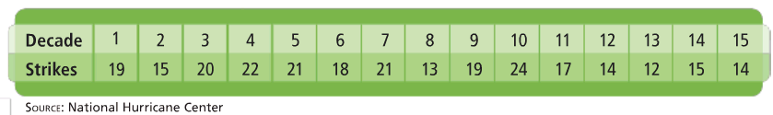

Example 7: The table displays the number of hurricanes in the Atlantic Ocean from 1992 to 2006.
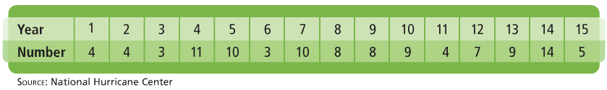
- What are the mean, standard deviation, and variance?

- Within how many standard deviations from the mean do all the values fall?

You Try! Find the mean, standard deviation, and variance of the following data values. Within how many standard deviations of the mean do all the data values fall: 12, 17, 15, 13, 9, 10, 12, 10, 15, and 17?

