Math 1 8.8 Solving Quadratics by Graphing Unit 8
SWBAT solve quadratic equations by graphing and using square roots.

Roots! Solutions! X-Intercepts! Zeros!
They all mean the same thing! What is the value of x when y is zero?!

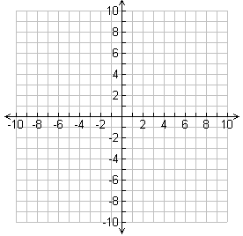
Two Solutions One Solution No Solution
.

Steps to Solve for “X” by Graphing
Step 1: Set the equation equal to zero.
Step 2: Put the left side of the equation into Y₁ =
Step 3: Put the right side of the equation into Y₂ =
Step 4: Hit “GRAPH”
Step 5: 2nd TRACE Intersect Enter 3 times
Step 6: Focus on the value of “x” (that’s what we are solving for!)
Step 7: Repeat steps 5 and 6 until you have found the value for all x-intercepts

Example 1: What are the solutions of each equation? Solve by graphing.

- x² = 1
- x² = 4x + 5
- x² – 6x = 9
- x² = –5

Solving Using Square Roots
Step 1: Make sure you have a binomial in the form y = ax² + c
Step 2: Get the variable by itself.
Step 3: How do you get rid of a square? Square root it!
**If you get an error message – it means we have No Solution**
Step 4: Remember – square roots always have two solutions (positive and negative)

Example 2: What are the solutions of each equation? Solve by taking square roots.

- 3x² – 75 = 0
- m² – 36 = 0
- 3x² + 15 = 0
- 4d² + 16 = 16

