Math 3 8.8 Inscribed Angles Unit 8
SWBAT apply the rules and theorems of inscribed angles to solve for unknowns.
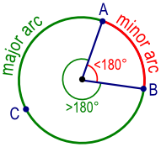
Major Arc: | Minor Arc: | Semicircle:
An arc of a circle measuring more than or equal to 180˚ | An arc of a circle measuring less than 180˚ | An arc of a circle measuring 180 ˚

Central Angle: | A central angle is an angle formed by two intersecting radii such that its vertex is at the center of the circle. | 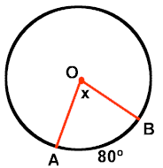
Central Angle Theorem: | In a circle, or congruent circles, congruent central angles have congruent arcs.

Example 1: Identify the following in ☉P at the right. For parts d-f, find the measure of each arc in ☉P.

- A semicircle
- A minor arc
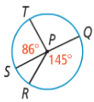
- A major arc

- $\hat{ST}$
- $\hat{STQ}$
- $\hat{RT}$

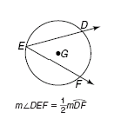
Inscribed Angle: | An inscribed angle is an angle with its vertex "on" the circle, formed by two intersecting chords.
Inscribed Angle Theorem: | The measure of an inscribed angle is half the measure of its intercepted arc.

Example 2: What are the values of a and b? You Try! What are the m$∠A$, m$∠B$, m$∠C$, and m$∠D$?
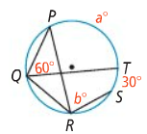
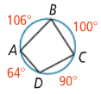

Corollary 1: | Corollary 2: | Corollary 3:
Two inscribed angles that intercept the same arc are congruent. 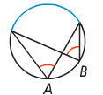 | An angle inscribed in a semicircle is a right angle.  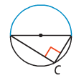 | The opposite angles of a quadrilateral inscribed in a circle are supplementary.  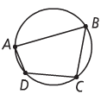

Example 3: What is the measure of each numbered angle?

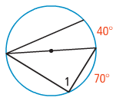
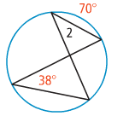

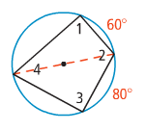
You Try! Find the measure of each numbered angle in the diagram to the right.

- $m∡1=$
- $m∡2=$

- $m∡3=$
- $m∡4=$

Tangent Chord Angle: | An angle formed by an intersecting tangent and chord has its vertex "on" the circle. | 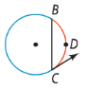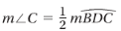
Tangent Chord Angle Theorem: | The tangent chord angle is half the measure of the intercepted arc.  Tangent Chord Angle = ½ (Intercepted Arc)

Example 4: In the diagram, $\overset{⃡}{SR}$ is tangent to the circle at Q. If $m\hat{PMQ}=212$, what is the $m∠PQR$?
You Try! In the diagram, $\overset{⃡}{KJ}$ is tangent to$⊙O.$ What are the values of x and y?

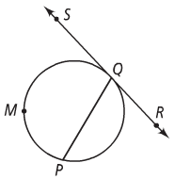
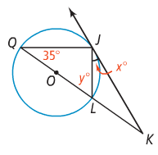

Practice: Find the value of each variable. For each circle, the dot represents the center.

